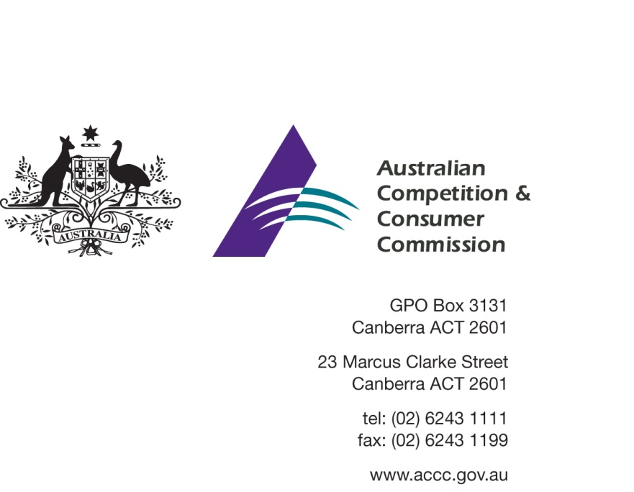

Our Ref: 54039
Contact Officer: Georgina Brett
Contact Phone: 03 9658 6439

14 April 2015

Dear Sir/Madam

Australian Childhood Foundation - Certification Trade Mark Application No 1585884 – interested party consultation

The Australian Competition and Consumer Commission (the ACCC) is considering an application to register a Certification Trade Mark (CTM) from the Australian Childhood Foundation (ACF).

Broadly, the CTM is intended to certify that organisations using the mark are accredited by the ACF under its Safeguarding Children Program as having best practice standards for protecting children and young people from abuse and exploitation whilst they participate in the organisation’s services and programs.

The ACF’s Safeguarding Children Program covers seven standards:
- commitments to safeguarding children
- personnel roles and conduct
- recruitment and screening practices
- personnel induction and training
- involving children and parents
- child abuse reports and allegations, and
- supporting a child-safe culture.

The ACF is an independent children’s charity which works to prevent child abuse and reduce the harm it causes to children, families and the community.

The ACCC invites you, as a potentially interested party, to comment on the ACF’s CTM application to assist the ACCC’s consideration of it.

ACCC’s role in assessing certification trade marks

A CTM indicates to consumers that a product or service meets a particular standard.

The ACCC’s role involves assessing and approving rules for the use of CTMs. In general terms, the ACCC is required to assess whether a CTM raises consumer protection, competition or associated concerns. In addition, the ACCC will assess the requirements that goods or services must meet in order to have a CTM applied to them.

More information about the process and the ACCC’s role in assessing CTMs can be found in the ACCC’s publication Certification Trade Marks – the role of the ACCC.

A copy of the CTM rules is available through the ACCC’s Consultation Hub at https://consultation.accc.gov.au/.

Request for comments

The ACCC invites you to comment on the application before it issues an initial assessment. Your comments may assist the ACCC in its consideration of this application.

If you wish to comment, please do so by Wednesday, 13 May 2014 to enable the ACCC to make a timely assessment of the application.

Comments should be emailed to adjudication@accc.gov.au with the subject “CTM1585884 – Australian Childhood Foundation – comment”.

The assessment of this CTM is a public process, and any comments or submissions may be placed on the ACCC’s website. If you wish to comment, but would like your comments to remain confidential, please note this clearly in your correspondence and briefly set out your reasons.

You can also forward this letter to any other party who may wish to make a comment to the ACCC regarding this application.

Please advise if you do not wish to make a comment at this time, but would like to be informed of the outcome of the ACCC’s initial and/or final assessment. If you are able to, please provide a nominated contact email address for future correspondence.

If you wish to discuss any aspect of this matter, please do not hesitate to contact Georgina Brett on 03 9658 6439.

Yours sincerely

[SIGNED]

Gavin Jones
Director
Adjudication Branch

