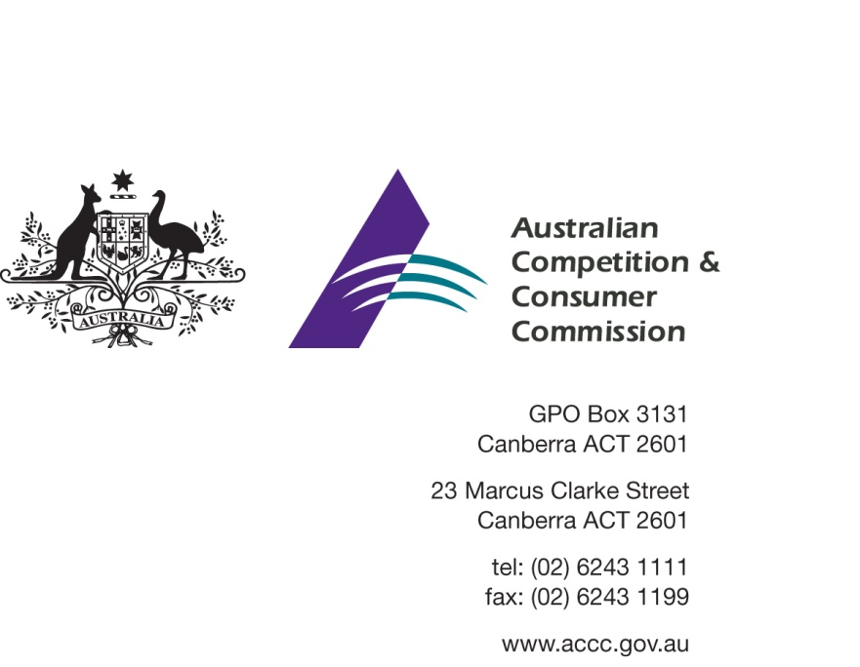

Our Ref: TRACKIT 57549
Contact Officer: Gina D’Ettorre
Contact Phone: 03 9290 1483

29 June 2015

Dear Sir/Madam

PROOF - Pasture Raised On Open Fields - Certification Trade Mark Application No 1635381 – interested party consultation

The Australian Competition and Consumer Commission (the ACCC) is considering an application to register a certification trade mark (CTM) from Pasture Raised On Open Fields Pty Ltd (PROOF). I am writing to you as a party who may be interested in commenting on the application.

Certification trade marks

A CTM certifies that a good or service is of a particular standard – for example, with regard to quality, origin, material or mode of manufacture. Registering a CTM under the Trade Marks Act 1995 (Cth) gives its owner the exclusive right to use the CTM and to allow other people to use it. Each CTM has rules that govern the use of the CTM and include the standards that goods or services must meet to bear the CTM and the processes the CTM owner uses to decide whether these standards have been met.

The CTM application

Broadly, PROOF’s CTM is intended to provide consumers with “proof” that the products bearing one of the symbols below has been produced from animals that have been treated ethically and raised in a free range production system.

The CTM rules provide a set of core values that apply to all categories of livestock and four separate standards setting out the minimum requirements for the farm practices relating to the production of pigs, poultry, meat sheep and beef cattle.

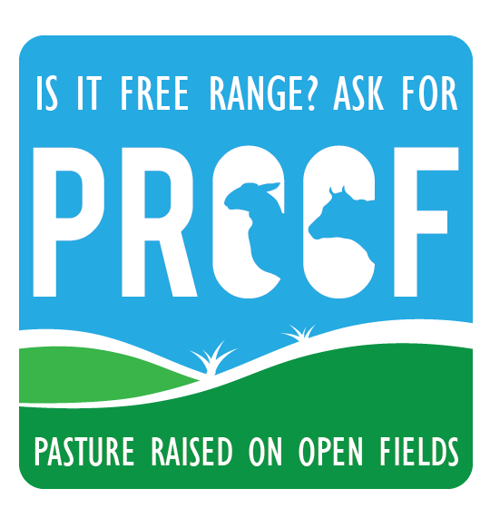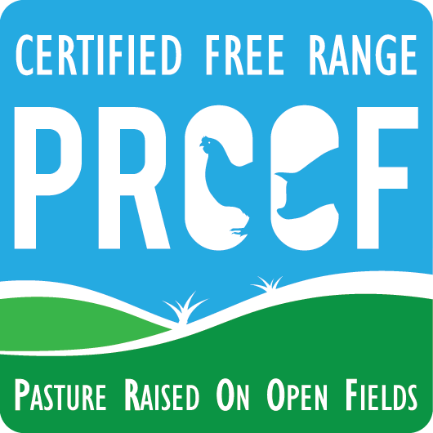

ACCC’s role in assessing certification trade marks

A CTM indicates to consumers that a product or service meets a particular standard.

The ACCC’s role involves assessing and approving rules for the use of CTMs. In general terms, the ACCC is required to assess whether a CTM raises consumer protection, competition or associated concerns. In addition, the ACCC will assess the requirements that goods or services must meet in order to have a CTM applied to them.

More information about the process and the ACCC’s role in assessing CTMs can be found in the ACCC’s publication Certification Trade Marks – the role of the ACCC.

A copy of the CTM rules is available through the ACCC’s Consultation Hub.

Consultation and next steps

The ACCC invites you to comment on the application before it issues an initial assessment. Your comments may assist the ACCC in its consideration of this application.

If you wish to comment, please do so by Monday, 27 July 2015 to enable the ACCC to make a timely assessment of the application.

Comments should be emailed to CTMs@accc.gov.au with the subject “CTM1635381 – PROOF – comment”.

The assessment of this CTM is a public process, and any comments or submissions may be provided to the Applicant or placed on the ACCC’s website. If you would like all or part of your submission to be treated as confidential, please indicate this clearly in your correspondence with reasons as to why you have made the request.

The ACCC will release an initial assessment of the application, which will be open to further public comment, and then a final assessment.

You may also forward this letter to any other party who may wish to make a comment to the ACCC regarding this application.

Please advise if you do not wish to make a comment at this time, but would like to be informed of the outcome of the ACCC’s initial and/or final assessment. If you are able to, please provide a nominated contact email address for future correspondence.

If you wish to discuss any aspect of this matter, please do not hesitate to contact Gina D’Ettorre on 03 9290 1483.

Yours sincerely
David Hatfield
Director
Adjudication Branch

