Statement of Issues
6 October 2016

News Corporation – proposed acquisition of APN News & Media Limited's Australian Regional Media division

Purpose
- News Corporation (News) proposes to acquire the Australian Regional Media division (ARM) of APN News & Media Limited (APN). News and ARM are the two largest newspaper publishers in Queensland and overlap in the supply of paid newspapers in many regions across Queensland, and also in the supply of free, community newspapers in several areas of south east Queensland.
- This Statement of Issues:
- gives the Australian Competition and Consumer Commission’s (ACCC’s) preliminary views on competition issues arising from the proposed acquisition
- identifies areas of further inquiry
- gives all interested parties an opportunity to comment
- invites interested parties to submit information to assist us in our assessment of the issues.

Overview of ACCC’s preliminary views
- The legal test which the ACCC applies in considering the proposed acquisition is in section 50 of the Competition and Consumer Act 2010. Section 50 prohibits acquisitions that would have the effect, or be likely to have the effect, of substantially lessening competition in any market.
- The ACCC divides its preliminary views into three categories: 'issues of concern', 'issues that may raise concerns' and ‘issues unlikely to raise concerns’. For this acquisition there are no ‘issues of concern’, three ‘issues that may raise concerns’, and two ‘issues unlikely to raise concerns’.

Issues that may raise concerns
- Supply of news and information to consumers/readers in certain Queensland regional centres: The ACCC’s preliminary view is that the proposed acquisition may be likely to substantially lessen competition in the supply of news and information to readers in the areas where ARM currently publishes paid newspapers due to the overlap with News’ The Courier Mail. The paid ARM newspapers include daily newspapers in:
  - Mackay
  - Rockhampton
  - Gladstone
  - Bundaberg
  - Hervey Bay
  - Gympie
  - Sunshine Coast
  - Toowoomba
  - Ipswich, and
  - Warwick.
In each of the above areas consumers/readers currently have a choice of the ARM newspaper or The Courier Mail, with both papers covering state, national and international news, providing a diversity of views. Following the proposed acquisition, News would supply one of two national newspapers (The Australian), the only Queensland-wide state newspaper (The Courier Mail) and the vast majority of Queensland paid regional newspapers.
- Supply of local news and information to consumers/readers: The ACCC’s preliminary view is that the proposed acquisition may be likely to substantially lessen competition in the supply of local news and information to consumers/readers in:
  - Caboolture/Bribie Island
  - south west Brisbane
  - Brisbane northern bayside
  - Logan, and
  - Tweed Heads/southern Gold Coast.
(together referred to as the local overlap areas)
In each of the above areas News and ARM publish free community newspapers (although in Tweed Heads/southern Gold Coast the overlap relates to both free and paid community newspapers) that have significant distribution overlaps. News and ARM both also have local news websites for these areas. The acquisition will reduce the choices that consumers/readers have for local news.
- Supply of local advertising opportunities to advertisers: The ACCC’s preliminary view is that the proposed acquisition may be likely to substantially lessen competition in the supply of local advertising opportunities to advertisers in the local overlap areas, namely:
  - Caboolture/Bribie Island
  - south west Brisbane
  - Brisbane northern bayside
  - Logan, and
  - Tweed Heads/southern Gold Coast
Local advertisers in those regions are likely to consider the ARM and News community publications close substitutes, and other options, such as local radio, television and pamphlets, may not be viable for certain advertisers.

Issue unlikely to raise concerns
- Supply of advertising opportunities in regional centres: The ACCC’s preliminary view is that the proposed acquisition is unlikely to raise competition concerns in relation to the supply of advertising opportunities in the Queensland regional centres where ARM currently publishes paid regional newspapers.
- Acquisition of content: The ACCC’s preliminary view is that the proposed acquisition is unlikely to raise competition concerns in relation to the acquisition of content from third party providers.

Making a submission
- The ACCC is seeking submissions from interested parties in relation to the proposed acquisition, particularly about:
- the extent to which The Courier Mail competes with ARM’s paid regional newspapers, including the daily ARM newspapers in Mackay, Rockhampton, Gladstone, Bundaberg, Hervey Bay, Gympie, the Sunshine Coast, Toowoomba, Ipswich and Warwick, and the other paid newspapers in the ARM portfolio, and the impact on consumers arising from the reduction in choice for readers in those locations
- the likely impact of common ownership of the News and ARM community newspapers in each of Caboolture/Bribie Island, south west Brisbane, Brisbane northern bayside, Logan and Tweed Heads/southern Gold Coast, including the impact on consumers arising from the reduction in choice
- whether community newspaper advertising rates would be likely to increase in Caboolture/Bribie Island, south west Brisbane, Brisbane northern bayside, Logan or Tweed Heads/southern Gold Coast following the acquisition.
- This Statement of Issues sets out further detail on these and other issues, along with specific questions.
- Interested parties should provide submissions by no later than 5pm on 27 October 2016. Responses may be emailed to mergers@accc.gov.au with the subject: Submission re: News/ARM - attention Lisa Campbell/David Wang. If you would like to discuss the matter with ACCC officers over the telephone or in person, or have any questions about this Statement of Issues, please contact Lisa Campbell on (02) 9230 9138 or David Wang on (02) 9230 3819.
- The ACCC anticipates making a final decision on 1 December 2016, however, this timeline may change. To keep abreast of possible changes in relation to timing and to find relevant documents, interested parties should visit the Mergers Register on the ACCC's website at www.accc.gov.au/mergersregister.

Confidentiality of submissions
- The ACCC will not publish submissions regarding the proposed acquisition. We will not disclose submissions to third parties (except our advisors/consultants) unless compelled by law (for example, under freedom of information legislation or during court proceedings) or in accordance with s155AAA of the Competition and Consumer Act 2010. Where the ACCC is required to disclose confidential information, the ACCC will notify you in advance where possible so that you may have an opportunity to be heard. Therefore, if the information provided to the ACCC is of a confidential nature, please indicate as such. Our Informal Merger Review Process Guidelines contain more information on confidentiality.

About ACCC ‘Statements of Issues’
- A Statement of Issues published by the ACCC is not a final decision about a proposed acquisition, but provides the ACCC’s preliminary views, drawing attention to particular issues of varying degrees of competition concern, as well as identifying the lines of further inquiry that the ACCC wishes to undertake.
- A Statement of Issues provides an opportunity for all interested parties (including readers/consumers, competitors, shareholders, advertisers and other stakeholders) to ascertain and consider the primary issues identified by the ACCC. It is also intended to provide News, APN and other interested parties with the basis for making further submissions should they consider it necessary.

Timeline

Date | Event
1 August 2016 | ACCC commenced review of the proposed acquisition
6 October 2016 | ACCC publication of Statement of Issues
27 October 2016 | Deadline for submissions from interested parties in response to this Statement of Issues
1 December 2016 | Anticipated date for ACCC final decision

The parties

News
- News Corporation (News) is a global media company with subscription television, magazines, newspapers and publishing operations and interests. In Australia, News publishes a number of state, regional and community newspapers as well as its national publication The Australian. It also publishes websites associated with many of its newspapers, as well as news.com.au and realestate.com.au. News also has a 48.95 per cent interest in carsguide.com.au and a minority interest in careerone.com.au.
- In Queensland and northern New South Wales, News supplies:
- The Australian, a paid Monday to Saturday newspaper distributed across Australia
- The Courier Mail, a metropolitan paid, daily newspaper distributed across Queensland. The Courier Mail is distributed Monday to Saturday and The Sunday Mail is distributed on Sundays
- paid regional newspapers in Cairns, Townsville, the Gold Coast and Bowen
- 17 free community newspapers (published through Quest Community Newspapers and Sun Community Newspapers), and
- a number of small paid non-daily and free publications circulating in Cairns and Townsville.

ARM
- APN News & Media Limited (APN) is an ASX-listed Australian company with media, radio, publishing and digital assets in Australia, and outdoor advertising assets in Australia, New Zealand and Hong Kong. The ARM division of APN, which is proposed to be sold to News, includes a large number of mostly regional/community publications in Queensland and northern NSW, including 12 paid daily, 14 paid non-daily and 32 free non-daily community newspapers.
- APN's radio and outdoor assets are not part of the proposed acquisition and will be retained by APN.
- The ARM business comprises:
- 58 regional/community newspapers circulating in various parts of south-east and regional Queensland and northern NSW, including:
  - 10 paid daily regional newspapers in Mackay, Rockhampton, Gladstone, Bundaberg, Hervey Bay, Gympie, the Sunshine Coast, Toowoomba, Ipswich and Warwick (including daily and weekend editions)
  - 14 paid non-daily regional newspapers, and
  - 32 free non-daily community newspapers.
- 14 specialist print newspapers including 'seniors', 'agriculture' and 'big rigs' titles
- 4 specialist business-to-business magazines for the education and health care sectors
- 60 websites including masthead websites, websites for the specialist print newspaper titles, other websites not linked to a print title and classifieds website finda.com.au, and
- printing facilities located in Yandina, Warwick and Rockhampton in Queensland.
- A full list of News and ARM’s publications in Queensland and New South Wales is provided at Attachment A.

Other industry participants

Fairfax
- Fairfax Media Limited (Fairfax) is a newspaper publishing group which operates in both Australia and New Zealand with an integrated metropolitan, rural, regional, print and online presence.
- Fairfax mastheads include The Sydney Morning Herald, The Age, The Australian Financial Review, BRW and The Sun-Herald.
- The ACCC understands that Fairfax publishes the following print newspapers in Queensland and associated online sites:
- The North West Star (paid tri-weekly newspaper published in Mt Isa)
- Beaudesert Times (paid weekly newspaper published in south east Queensland)
- Goondiwindi Argus (paid weekly newspaper published in south east Queensland)
- Redland City Bulletin (paid weekly newspaper published in south east Brisbane)
- Jimboomba Times (free weekly newspaper published in south east Queensland)
- North Queensland Register (paid weekly rural newspaper published in far north Queensland)
- Three other agricultural titles: Queensland Cotton & Grains Outlook, Queensland Country Life and Queensland Smart Farmer
- Fairfax also publishes the online-only Brisbanetimes.com.au and related sites MyBT Gold Coast, MyBT Toowoomba and MyBT Ipswich.
- In New South Wales, Fairfax publishes a much larger number of regional newspapers.

Independent publishers
- There are independent publishers of print and online newspapers or magazines in some local areas of Queensland and northern New South Wales. The discussion of the local overlap areas below lists the independent publications that the ACCC is aware of in those areas.
- In general, the frequency of publication, readership and circulation of these publications are less than the parties’ newspapers.

Background

Changes in how consumers access news
- The newspaper industry has been subject to significant change over the last decade. The ways in which consumers access news and information, and hence the media platforms used by advertisers to target potential customers, have been changing. Traditional media models in the form of print newspapers are facing increasing challenges from other modes of delivery. Many established incumbents have responded by creating their own online news sites that allow content to be accessed via desktop, tablets and mobile devices.
- In contrast to the print media industry, digital media has been growing, with many consumers switching their news consumption from print to digital media, or supplementing their print news consumption with digital news. Digital media includes online news sites (including digital editions of newspapers), social media and video/streaming services. Unlike online news sites, social media tends to aggregate and present news and information to consumers, as opposed to producing or generating such content.
- Where an industry is growing rapidly, this may facilitate new entry or expansion and erode the market shares of established incumbents. However, the ongoing financial viability of new online providers is dependent on their ability to monetise their content.

Terminology
- In this Statement of Issues:
- “regional” newspapers refers to paid newspapers (i.e. newspapers which have a cover price) published outside major metropolitan areas (which in this matter are Brisbane and the Gold Coast). These generally have a local focus, but also contain broader regional, state, national and international news.
- “community” newspapers refers to newspapers largely focussed on local community news which are delivered to households or otherwise made available for free (i.e. there is no cover price). They may be distributed in either metropolitan or regional areas.

Areas of overlap
- ARM and News (through ownership of The Courier Mail) overlap in the supply of paid, daily regional newspapers (and associated websites) in each of the following areas:
- Mackay
- Rockhampton
- Gladstone
- Bundaberg
- Hervey Bay
- Gympie
- the Sunshine Coast
- Toowoomba
- Ipswich, and
- Warwick.
- There is also some overlap between The Courier Mail and ARM’s paid, non-daily (i.e. weekly or bi-weekly) regional newspapers, which are published in the Whitsundays; Biloela and surrounds; Emerald, Barcaldine and surrounds; Childers and surrounds; Biggenden and surrounds; Stanthorpe; Dalby; Kingaroy and surrounds; the St George region; Roma; Charleville, Cunnamulla and surrounds; Chinchilla and Tweed Heads.
- The overlap between ARM’s paid regional papers and The Courier Mail (and the associated websites) is mostly in relation to the provision of state, national and international news. There is limited overlap in relation to local or regional news, as this will not generally be covered in The Courier Mail.
- The proposed acquisition would result in News owning the vast majority of print newspapers in Queensland. It would own paid newspapers in almost all of the 20 largest population centres in Queensland, the main exception being Mt Isa (where the local newspaper is published by Fairfax).
- As noted above, News and ARM also overlap in the supply of community (free) newspapers and associated websites in the local overlap areas, namely:
- Caboolture/Bribie Island
- South west Brisbane
- Brisbane Northern Bayside
- Logan, and
- Tweed Heads/southern Gold Coast region (in this region there is also overlap from two of the parties’ paid publications: News’ Gold Coast Bulletin and ARM’s Tweed Daily News (weekend edition)).
- There are also some more minor geographic overlaps between the parties’ community and regional newspapers in the following regions:
- Proserpine/Cannonvale/Airlie Beach
- Bowen
- Mackay
- Ipswich, and
- Byron Bay/Brunswick Heads.
- Attachment A lists the parties’ publications in each of these regions.

Market definition
- The ACCC’s starting point for defining relevant markets is identifying the products and geographic regions actually or potentially supplied by the parties. The ACCC then focuses on areas of activity where competitive harm could occur as a result of the proposed acquisition.
- The ACCC focuses on two key dimensions of substitution in characterising markets: the product dimension and the geographic dimension. These are discussed below.

Two-sided markets
- Most markets in the media industry, including the supply of newspapers, can be characterised by their interdependent two-sided nature. Media companies acquire or develop content to attract consumers, which in turn attracts advertisers. Each of News and ARM supply newspapers and associated online news sites that supply news and information to readers and advertising opportunities to advertisers who wish to reach those readers.
- It is necessary to consider the interrelated nature of demand. For example, an increase in demand by readers on a particular platform will be likely to lead to an increase in demand from advertisers for advertising on the other side of the same platform.
- Although this Statement of Issues identifies two separate issues in relation to the supply of local news and information to consumers, and the supply of local advertising opportunities to advertisers, the ACCC recognises the analysis of competition on one side of the newspaper ‘platform’ cannot be isolated from the analysis of competition on the other side.

Product dimension
- News and ARM overlap in relation to the supply of both print newspapers and online news. Therefore, it is relevant to consider the effects of the proposed acquisition on the supply of both products.
- Newspapers generally contain a mix of different categories of news (although community newspapers focus almost exclusively on local news), as well as entertainment/lifestyle content and sport. The ACCC understands that many newspaper readers value the “package” of content that newspapers provide. Although for each category of content there is likely to be a number of alternative sources for similar content (e.g. for rugby league news readers could go directly to the NRL website), many readers value the ability to read a bundle of different kinds of news and information in a single, convenient format. Advertisers also value the ability to reach a wide circulation of these readers by advertising in newspapers.
- Accordingly, a principal issue for the ACCC is the extent to which the removal of a key supplier of bundled “packages” of news and other content (by way of community and regional newspapers) would substantially lessen competition.

Type of news – local, state, national etc
- The ACCC considers that it is unlikely to be necessary or appropriate to draw distinct boundaries between the supply of local, state, national and international news. However, the degree of competitive overlap between different newspapers will vary depending on the proportion of each type of content they include (as well as other factors, such as their frequency of publication). Accordingly:
- community newspapers, which are generally published weekly, are likely to compete most closely with other community newspapers
- community newspapers are likely to compete to some degree with regional newspapers, as both supply local/regional news and information. However, a weekly community newspaper is unlikely to closely compete with a paid daily newspaper, as the paid daily paper will have a much wider focus, and
- daily state/metropolitan newspapers such as The Courier Mail compete with paid regional newspapers (particularly daily ones), as they both cover state, national and international news, but are unlikely to compete to any significant extent with community newspapers, due to the different content and frequency.

From a reader/consumer perspective
- There are a number of other sources of news and information that may be considered alternatives for print or online news by some consumers, including radio and television. However, the extent to which consumers consider these other media to be substitutable for print news, or online news, and therefore the level of competitive constraint they impose on suppliers of print or online news, will vary.
- In relation to online news sites as an alternative for print news, there are at least two factors that limit the extent of this substitutability:
- many consumers, particularly those in the older demographic groups, still value the ability to read a bundle of news and information in the print format, even if they also have access to and use the internet, and
- limited availability of affordable and sufficiently fast broadband internet in many areas of regional and rural Queensland limits the ability of consumers in those areas to access online news.
- The ACCC notes that News and ARM are also major suppliers of online news in Queensland through websites such as Couriermail.com.au, Goldcoastbulletin.com.au and Cairnspost.com.au (News); and Sunshinecoastdaily.com.au, www.dailymercury.com.au and www.thechronicle.com.au (ARM).
- Radio is an important source of news and information for many consumers, particularly older consumers and those in regional or rural areas. However, the different format of radio news means that it is not necessarily a close substitute for print news, and may instead be considered a complementary product by consumers. Also in some areas, particularly greater Brisbane/south east Queensland, radio may not provide sufficiently localised content to be considered a substitute for community newspapers.
- Similarly, television is a significant source of news for many consumers, but in a very different format from print newspapers and may also be considered a complement to print news. In regional and rural areas of Queensland, television news also may not provide the same proportion of local content that regional newspapers and radio news provide. Also, television does not provide local news of the type which is published in community newspapers.

From an advertiser perspective
- There are a variety of platforms available to advertisers. The choice of delivery mode will be influenced by the product, the group of potential customers that advertisers are seeking to target, and whether or not the advertisement is time sensitive. As noted above, advertisers’ demand for advertising opportunities is interrelated with readers’ demand for news. Accordingly, any changes in consumer preferences for accessing news is likely to influence advertisers’ choice of advertising platform.
- The ACCC recognises that modes of delivery which superficially look very different may nonetheless be viewed as alternative advertising options for advertisers. For instance, an advertiser may, to some extent, view placing advertisements through Google or Facebook as an alternative to placing advertisements in a print publication so long as each option enables the advertiser to present to target consumers in an effective way. As with the discussion of local news/information, however, substitution opportunities for advertisers – and therefore the competitive constraint they apply – are a matter of degree.
- Given the proposed acquisition reduces the number of newspaper providers in the local overlap areas and across Queensland more broadly, a key issue for the ACCC is whether or not advertising via other platforms is a substitute for print newspapers.

Geographic dimension
- As a starting point, it is relevant to consider the geographic areas in which the parties’ publications overlap. This does not mean that competitive constraints from outside these areas should be ignored.
- Therefore, the ACCC is considering the potential effects of the proposed acquisition primarily in the following geographic areas.
- First, the local overlap areas in south east Queensland where the (primarily) community publications of News and ARM overlap:
- Caboolture/Bribie Island
- south west Brisbane
- Brisbane northern bayside
- Logan, and
- Tweed Heads/southern Gold Coast.

- Second, the cities, towns or regions in which News and ARM overlap in the supply of paid newspapers, in particular, those where ARM currently publishes a paid daily newspaper, being:
- Mackay
- Rockhampton
- Gladstone
- Bundaberg
- Hervey Bay
- Gympie
- the Sunshine Coast
- Toowoomba
- Ipswich, and
- Warwick.
The ACCC invites comments from market participants on its preliminary views about the relevant markets. In particular:
For readers of the community newspapers in south west Brisbane, Caboolture/Bribie Island, Logan, Brisbane northern bayside and Tweed Heads/southern Gold Coast:
- Do you read your community newspaper(s)? If so, please identify which community newspaper(s) you read. Do you also access local news through their online news sites?
- If you do not read your community newspaper, why not? Where do you obtain your local news and information?
- Does your community newspaper offer any particular types of news or information, or features (such as lift-outs and inserts) that make it different from other news sources?
- If the quality of content was reduced in your community newspaper(s), would you switch to obtaining more news and information online or via other media platform such as radio or social media? If so, which media platform would you obtain more of your news from? If not, why not?
For local advertisers in south west Brisbane, Caboolture/Bribie Island, Logan, Brisbane northern bayside and Tweed Heads/southern Gold Coast:
- What are your main sources for advertising? Why?
- Does advertising in your community newspaper provide any distinguishing features that are not provided by other forms of advertising (e.g. distribution areas, cost)?
- If the prices of community newspaper advertising were to rise by 5 to 10 per cent, would you switch to advertising more online or via other modes of delivery such as local radio, letterbox drops, outdoor advertising or social media? If so, which other forms of advertising would you switch to? If not, why not?
For newspaper readers in regional areas, including those in Mackay, Rockhampton, Gladstone, Bundaberg, Hervey Bay, Gympie, the Sunshine Coast, Toowoomba, Ipswich and Warwick:
- Which newspapers do you regularly buy and what are the main reasons you buy each paper?
- Do you switch between reading the regional paid newspaper and The Courier Mail? Do you consider the local regional paid newspaper and The Courier Mail to be substitutes?
- If the price of the local regional paid newspaper increased by 5 to 10 percent (e.g. an 8-15 cents increase for a weekday local paper), would you switch to reading The Courier Mail? If not, would you switch to a different publication or source of news?
- If the quality of the local regional paid newspaper decreased would you switch to reading The Courier Mail? If not, would you switch to a different publication or source of news?

Issue that may raise concerns – loss of competition between The Courier Mail and ARM regional newspapers
- The ACCC is concerned that the proposed acquisition may be likely to substantially lessen competition in the supply of news and information to readers in the areas where ARM currently publishes its paid regional newspapers.
- As explained above, News (through The Courier Mail) and ARM overlap in the supply of paid, daily newspapers (and associated websites) in each of the following areas:
- Mackay
- Rockhampton
- Gladstone
- Bundaberg
- Hervey Bay
- Gympie
- the Sunshine Coast
- Toowoomba
- Ipswich, and
- Warwick.
- As was noted earlier, if the proposed acquisition proceeds, News would own the vast majority of print newspapers in Queensland. It would own paid newspapers in almost all of the 20 largest population centres in Queensland, the main exception being Mt Isa (where the local newspaper is published by Fairfax).
- The ARM’s regional newspapers cover state, national and international news (including sport). There is overlap with The Courier Mail in respect of these news categories.
- However, a significant proportion of the content in ARM’s regional newspapers is also local or regional news and information. There is limited overlap with The Courier Mail in relation to the supply of this type of news, because The Courier Mail’s local/regional news content is focussed on the greater Brisbane/south east Queensland area.
- The ACCC understands that the state, national and international content currently supplied by ARM is typically similar across its Queensland papers. Some of this content is sourced from third parties, including Independent News & Media and News.
- The ACCC considers that The Courier Mail and the ARM paid regional newspapers are currently alternatives for at least some consumers. The ability for consumers to choose between The Courier Mail and a local ARM paper imposes at least a degree of competitive constraint on News and ARM in their pricing and in terms of the quality of content. This constraint may be considered significant given the lack of other close competitors (i.e. there are no other paid daily newspapers).
- The ACCC is concerned that the proposed acquisition may:
- reduce choice for readers, in terms of editorial content and perspective on news stories
- lead to a reduction in the quality of content contained in the newspapers and/or online
- lead to a reduction in the total offering (for instance, News discontinuing one or more of ARM’s newspapers).
- Each of these potential effects of the proposed acquisition is likely to cause consumer detriment. Part of that detriment is a possible loss of ‘diversity’. ‘Diversity’ in a media context broadly refers to the range of media ‘voices’ available to consumers. The diversity of media voices is interlinked with a number of issues the ACCC considers in its competition assessment under section 50 of the Competition and Consumer Act 2010.
- If a publisher has a history of supplying its own differentiated content in order to attract consumers, its acquisition by another publisher might give the acquirer the ability and incentive to reduce or cease the supply of this content without risking a significant loss of sales. This reduction of choice available to consumers post-acquisition, among other factors, may have the effect of substantially lessening competition, while also reducing media diversity.
- Because the proposed acquisition increases concentration in the supply of news and information in various areas of Queensland, it is likely to reduce the diversity or number of ‘voices’ and result in a reduction in the quality or differentiation of the news and information.
- This reduction in quality or differentiation may occur if News decides to, for example:
- employ fewer journalists
- reduce the amount of local/regional content in the ARM newspapers, replacing it with more state, national or international content sourced from other News publications, or
- alter the types of stories covered in the ARM newspapers or change the angle of reporting on certain issues, leading to a loss of ARM’s alternate ‘voice’ and therefore a loss of diversity.
- It may also be profitable for News to increase the cover price for the ARM regional newspapers, or introduce paywalls for more of its online content.
- Without the proposed acquisition, ARM may be concerned that lowering quality or raising prices may lead to a loss of sales to The Courier Mail in a way that would make such a price rise/quality reduction unprofitable. With the proposed acquisition, a price rise/quality reduction for an ARM publication may become profitable for News because any sales lost to The Courier Mail will be captured in-house, and generate additional revenue for News.
- However, whether News would be likely to take such steps post-acquisition will be affected by:
- how closely the ARM newspapers currently compete with The Courier Mail, that is, what proportion of consumers consider The Courier Mail to be an alternative to their local ARM regional newspaper
- the alternatives available to readers in the areas where ARM currently publishes paid regional newspapers.
- While in some of the relevant regions there may be a degree of constraint from independent, non-daily newspapers, the lesser frequency and smaller distribution areas of these publications lessens the level of competition they could impose.
- The ACCC considers that barriers to entry for a potential new publisher of paid daily newspapers are likely to be significantly higher than for community newspapers, due to the much larger scale of such an operation and the higher costs associated with editorial content, printing and distribution. Therefore News is unlikely to be constrained by the threat of entry by new regional paid daily newspapers.
- The similar format of the News and ARM papers means that they are likely to be close competitors. The ACCC accepts that other sources of news, such as local radio stations (which exist in nearly all of the locations of the paid regional ARM papers) and television, are alternatives to newspapers for some consumers. However, the different format of these platforms means that not all consumers will consider them acceptable alternatives.
- Online news is likely to be considered a substitute by many consumers. However, post-acquisition News will also have a very strong presence in the supply of online news in Queensland. The ACCC will consider what alternative online sources for regional news will be available post-acquisition, such as ABC Online and Fairfax’s websites. As noted above, the ACCC will also take into account the limited availability of affordable, sufficiently fast broadband in many areas of regional and rural Queensland.
The ACCC invites comments from market participants on the following:
- What is the likely impact on reader choice and diversity of news in the relevant regional centres if the acquisition proceeds?
- Is there currently significant competition between News and ARM in the supply of news and information in Mackay, Rockhampton, Gladstone, Bundaberg, Hervey Bay, Gympie, the Sunshine Coast, Toowoomba, Ipswich and Warwick (and the locations of the other paid papers in the ARM portfolio), e.g. in terms of quality, price or breaking news stories? Please explain your view.
- Is The Courier Mail an alternative for readers of the ARM paid newspapers? For example, do readers choose between the two newspapers depending on their content, or do they always buy the same one (or do they buy both)?
- In relation to state, national and international news (including sport), do the ARM regional newspapers provide a different perspective from The Courier Mail, for example in terms of the stories covered or the angle they take on the same stories?
- What do you consider is the likely impact on price, content and quality of News buying the ARM paid newspapers?
- Are online news sites a good substitute for print newspapers in regional areas of Queensland? Please explain why. If online new sites are substitutes for the ARM local paper, please identify which ones.
- Are television and radio news and information good substitutes for the print and online news and information provided by newspapers in the relevant regional areas? Please explain why.

Issue that may raise concerns – reduction in competition in supply of news and information to readers/consumers in local overlap areas
- Based upon its inquiries to date, the ACCC’s preliminary view is that the proposed acquisition may be likely to substantially lessen competition in the supply of news and information (print and online) to readers/consumers in the local areas where News’ and ARM’s community (free) publications overlap, in particular:
- Caboolture/Bribie Island
- south west Brisbane
- Brisbane northern bayside
- Logan, and
- Tweed Heads/southern Gold Coast
(as was noted earlier, these are defined as the local overlap areas)
- The concerns expressed above in paragraphs 64-67 concerning the reduction in media diversity post-acquisition also apply in relation to the effect of the proposed acquisition on the supply of community newspapers in the local overlap areas.
- The ACCC considers that News and ARM are likely to be each other’s closest competitors in the local overlap areas, due to the extent of the overlap between their community publications and the lack of competing publications with similar distribution areas.
- In each of the local overlap areas, there are some alternative sources of local news and information. These vary between the different areas, but generally include some or all of:
- other local newspapers, magazines or newsletters.
- local websites, and
- local radio stations.
- The sections below on each of the local overlap areas set out potential alternative sources of news and information of which the ACCC is aware.
- Alternative local newspapers in the local overlap areas generally have different circulation areas and are much smaller or in a different format from the News and ARM publications. In general most of the non-advertising content of these alternative publications is simple reporting about local events (e.g. an upcoming local festival). In contrast, News’ and ARM’s community newspapers are more likely to contain reporting on issues such as planning disputes, council elections and local crime, as well as the less significant news.
- Even where other sources of supply, such as alternative online news providers, radio and television, provide some level of competitive constraint for some types of content for some consumers, they may not be able to offer the same level of competitive constraint as the print newspapers provide to each other.
- Further, despite a general industry trend of declining circulation and readership of newspapers, there appear to still be a group of consumers that do not consider other sources of news and information to be substitutes for print newspapers. The size of this group of readers is declining, but the proposed acquisition has the potential to adversely affect them.

Barriers to entry
- The ACCC is considering the extent to which the threat of entry by new community newspapers in the local overlap areas may constrain News from increasing prices or reducing quality post-acquisition.
- The ACCC understands that there have been instances of new community newspapers commencing in some local areas of Queensland in recent years.
- Barriers to commencing publication of a community newspaper may be relatively low, if done on a small scale, with the backing of a group of advertisers, and provided that access to third party printing facilities is available.
- On the other hand, the general industry trend of decline in print publications and move towards online platforms is likely to affect incentives to enter.
- Barriers to entry for a new online-only local publication are likely to be low. However, in order for such a website to gain sufficient scale to impose a competitive constraint on News, it would need to attract both viewers and advertisers, which is likely to be more difficult and costly. The ACCC understands that many online news providers have struggled to attract sufficient advertising revenue, even where they have a substantial audience.

South west Brisbane
- News’ South West News overlaps with ARM’s The Satellite as set out in the table and map of the approximate distribution areas below.
Table 1: Publication, distribution and circulation details of South West News (News) and The Satellite (ARM)
Party | Title | Published | Circulation* (print) | Distribution suburbs
News | South West News  (couriermail.com.au/  questnews/southwest) | Weekly, Wed  (free) | 55,028  (October 2014 to March 2015) | Bellbird Park, Carole Park, Collingwood Park, Corinda, Darra, Doolandella, Durack, Ellen Grove, Forest Lake, Gailes, Goodna, Heathwood, Inala, Jamboree Heights, Jindalee, Middle Park,  Mt Ommaney, Oxley, Pallara, Redbank, Redbank Plains, Riverhills, Rocklea, Seventeen Mile Rocks, Sinnamon Park, Sumner, Wacol, Westlake
ARM | The Satellite  (thesatellite.com.au) | Weekly, Wed | 42,361  (October 2015 to March 2016) | Bellbird Park, Brookwater, Camira, Collingwood Park, Corinda, Darra, Durack, Forest Lake, Gailies, Goodna, Inala, Jamboree Heights, Jindalee, Middle Park, Mount Ommaney, Oxley, Redbank, Redbank Plains, Riverhills, Seventeen Mile Rocks, Sinnamon Park, Springfield, Springfield Lakes, Wacol, Westlake
*Source: emmaTM conducted by Ipsos MediaCT, 12 months ending March 2016. CAB, March 2016 included on http://www.newscorpaustralia.com/our-brands and http://apnarm.com.au/print/

Figure 1: Map of the distribution areas of South West News (News) and The Satellite (ARM)
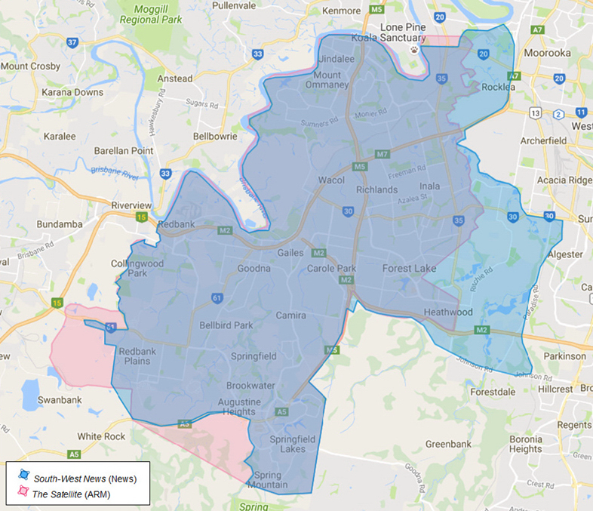
Map source: Google; distribution information obtained from News and ARM websites
- Other potential alternative sources of local news in the south west Brisbane area include:
- Ipswich Life, an independent fortnightly print publication with a circulation of 30,000 distributed in Ipswich city and the greater Ipswich region.
- The following independent, monthly publications:
  - The Lake News (limited geographic overlap with The Satellite)
  - The Local Bulletin
  - The Greater Springfield Times (limited geographic overlap with The Satellite)
  - Centenary News (limited geographic overlap with The Satellite)
- Radio stations are unlikely to be a source of comparable local news, as the radio stations in this area appear to cover the whole of Brisbane and are therefore unlikely to provide more than a minimal amount of news specific to the south west Brisbane area.

Caboolture/Bribie Island
- News’ Caboolture Herald overlaps with ARM’s Caboolture News and Bribie Weekly as set out in the table and map of the approximate distribution areas below.
Table 2: Publication, distribution and circulation details of Caboolture Herald (News), Caboolture News (ARM) and Bribie Weekly (ARM)
Party | Title | Published | Circulation* (print) | Distribution suburbs
News | Caboolture Herald (couriermail.com.au/  questnews/moreton) | Weekly, Thurs | 37,741  (October 2014 to March 2015)) | Banksia Beach, Beachmere, Bellara, Bellmere, Burpengary, Burpengary East, Caboolture, Commercial, Godwin Beach, Morayfield, Narangba, Ningi, Sandstone Point, Upper Caboolture, Wamuran
ARM | Caboolture News (caboolturenews.com.au) | Weekly, Wed | 33,710  (October 2015 to March 2016) | Beachmere, Beerburrum, Beerwah, Burpengary, Caboolture, Deception Bay, Donnybrook, Elimbah, Kilcoy, Morayfield, Narangba, Peachester, Toorbul, Wamuran, Woodford
 | Bribie Weekly | Weekly, Fri | 12,540 (October 2015 to March 2016) | Bongaree, Bribie Island, Godwin Beach, Ningi, Sandstone Point, Welsby, White Patch, Woorim
*Source: emmaTM conducted by Ipsos MediaCT, 12 months ending March 2016. CAB, March 2016 included on http://www.newscorpaustralia.com/our-brands and http://apnarm.com.au/print/
Figure 2: Map of the distribution areas of Caboolture Herald (News), Caboolture News (ARM) and Bribie Weekly (ARM)
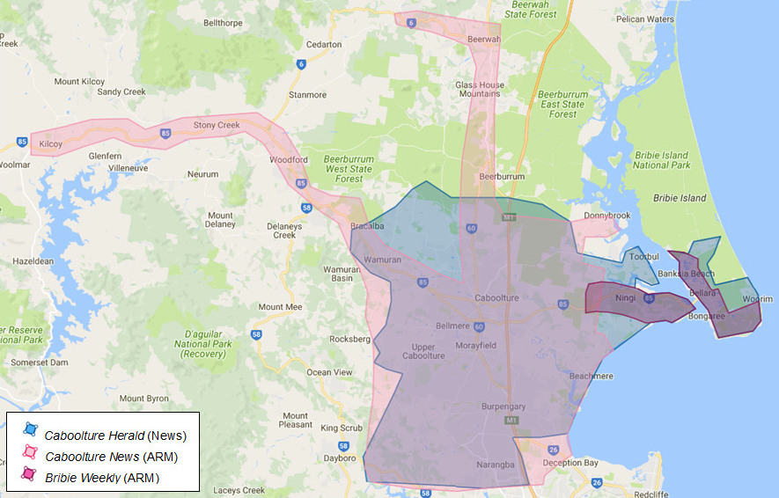
Map source: Google; circulation information obtained from News and ARM websites

- Other potential alternative sources of news in the Caboolture/Bribie Island area include:
- Our Narangba & Burpengary, an independent monthly print publication with a small circulation and readership, distributed in Narangba and Burpengary, plus the associated website ournarangba.com.au.
- The Bribie Islander, a free independent monthly publication with a distribution of 15,000.
- The following publications which publish a limited amount of local news or information:
  - 4510TV in Caboolture (Independent), a website featuring video, images and other publications focussed on Caboolture and surrounding areas
  - Our Bribie (Independent), a website providing local news in relation to Bribie Island and other content
  - My Town Magazine Moreton Bay Region (Independent), published monthly
- Community radio station 101.5FM, an independent community radio station broadcasting from a studio in Caboolture to the Moreton Bay region including Caboolture, Burpengary and Morayfield, and associated website 1015fm.com.au/category/news/.

Brisbane northern bayside
- News’ Northside Chronicle overlaps with ARM’s Bayside & Northern Suburbs Star as set out in the table and map of the approximate distribution areas below.
Table 3: Publication, distribution and circulation details of Northside Chronicle (News) and Bayside & Northern Suburb Star (ARM)
Party | Title | Published | Circulation* (print) | Distribution suburbs
News | Northside Chronicle (couriermail.com.au/  questnews/north) | Weekly, Wed | 62,162  (October 2014 to March 2015) | Aspley, Banyo, Boondall, Bracken Ridge, Bridgeman Downs, Brighton, Carseldine, Chermside, Chermside West, Deagon, Eagle Farm, Fitzgibbon, Geebung, Kedron, Northgate, Nudgee, Nundah, Sandgate, Shorncliffe, Taigum, Toombul, Virginia, Wavell Heights, Zillmere
ARM | Bayside & Northern Suburb Star (baysidestarnews.com.au) | Weekly, Wed | 37,453  (October 2015 to March 2016) | Aspley, Bald Hills, Boondall, Bracken Ridge, Brighton, Carseldine, Deagon, Fitzgibbon, Geebung, Sandgate, Shorncliffe, Taigum, Virginia, Zillmere
*Source: emmaTM conducted by Ipsos MediaCT, 12 months ending March 2016. CAB, March 2016 included on http://www.newscorpaustralia.com/our-brands and http://apnarm.com.au/print/
Figure 3: Map of the distribution areas of Northside Chronicle (News) and Bayside & Northern Suburb Star (ARM)
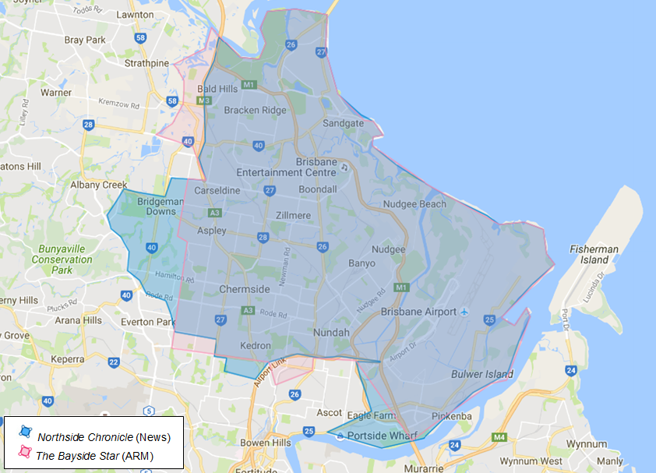
Map source: Google; circulation information obtained from News and ARM websites
- Other potential alternative sources of news and information in the Brisbane northern bayside area include the following independent print publications:
- The Messenger, a free weekly publication (including real estate and classifieds advertising) with a small circulation distributed to the North Lakes development area and other parts of the Moreton Bay region, and associated website northlakesmessenger.com.au
- Sandgate Guide, a monthly publication and associated website sandgate.com.au/sandgate-guide.html
- Albany Creek Buzz, which is distributed approximately quarterly, and associated website brisbanebuzzmagazines.com.au/read-online
- Radio stations are unlikely to be a source of comparable local news, as the radio stations in this area appear to cover the whole of Brisbane and are therefore unlikely to provide more than a minimal amount of news specific to the Brisbane northern bayside area.

Logan
- News’ Albert & Logan News overlaps with ARM’s The Logan Reporter as set out in the table and map of the approximate distribution areas below.
Table 4: Publication, distribution and circulation details of Albert & Logan News (News) and The Logan Reporter (ARM)
Party | Title | Published | Circulation* (print) | Distribution suburbs
News | Albert & Logan News (couriermail.com.au/  questnews/logan) | Weekly, Thurs | 74,451  (October 2014 to March 2015) | Bahrs Scrub, Beenleigh, Berrinba, Bethania, Boronia Heights, Browns Plains Cornubia, Crestmead, Daisy Hill, Drewvale, Eagleby, Edens Landing, Forestdale, Heritage Park, Hillcrest, Holmview, Kingsholme, Kingston, Logan Central, Logan Reserve, Logan Village, Loganholme, Loganlea, Marsden, Meadowbrook, Mt Warren Park, Park Ridge, Park Ridge South, Regents Park, Rochedale South, Shailer Park, Slacks Creek, Springwood, Stretton, Tanah Merah, Underwood, Waterford 13, Waterford West, Windaroo, Woodridge, Yatala
ARM | The Logan Reporter  (thereporter,com.au) | Weekly, Fri | 51,187  (October 2015 to March 2016) | Boronia Heights, Browns Plains, Crestmead, Daisy Hill, Greenbank, Heritage Park, Hillcrest, Kingston, Logan Central, Logan Village, Loganlea, Marsden, Meadowbrook, Park Ridge, Regents Park, Rochedale South, Shailer Park, Slacks Creek, Springwood, Tanah Merah, Underwood, Waterford, Waterford West, Woodridge
*Source: emmaTM conducted by Ipsos MediaCT, 12 months ending March 2016. CAB, March 2016 included on http://www.newscorpaustralia.com/our-brands and http://apnarm.com.au/print/

Figure 4: Map of the distribution areas of Albert & Logan News (News) and The Logan Reporter (ARM)
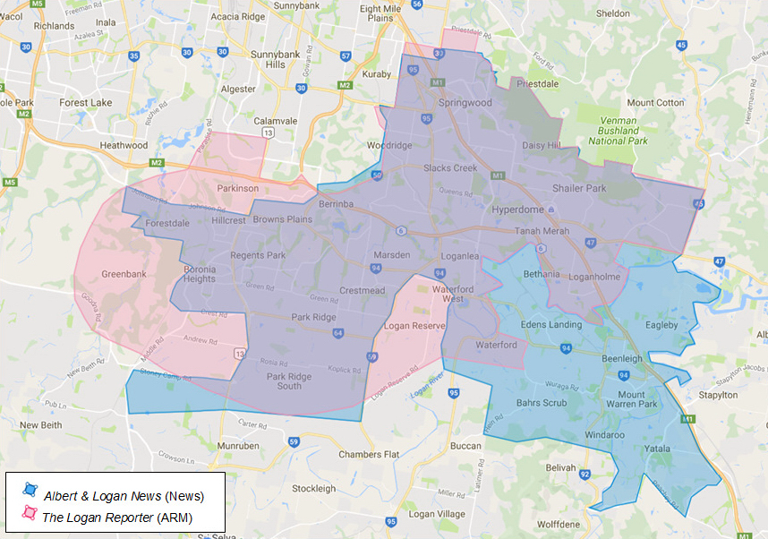Map source: Google; circulation information obtained from News and ARM websites
- Other potential alternative sources of news in the Logan area include:
- the following print publications:
  - South City Bulletin, an independent monthly publication (currently printing 38,000 copies per month) covering nearly 30 suburbs on the southern side of the greater Brisbane metropolitan area, including Springwood, Loganholme and Meadowbrook and associated website southcitybulletin.com.au/
  - Fairfax’s Jimboomba Times, a free weekly publication distributed in the Jimboomba region and associated website jimboombatimes.com.au. However, the geographic overlap between the Jimboomba Times and the News and ARM newspapers is limited, and
  - Fairfax’s Redland City Bulletin, a paid weekly publication distributed in the Redland City region and associated website redlandcitybulletin.com.au. However, the geographic overlap between Redland City Bulletin and the News and ARM newspapers is limited.
- Community radio station 101FM, based in Logan and broadcasting to south east Queensland

Tweed Heads/southern Gold Coast
- News’ local publications overlap with ARM’s local publications in the Tweed Heads/southern Gold Coast region as set out in the table and map of the approximate distribution areas below.
- In this region there are overlaps between both regional (paid) and community (free publications) of News and ARM.
Table 5: Publication, distribution and circulation details of Tweed/Southern Sun (News), Gold Coast Bulletin (News) and Tweed Daily News (ARM)
Party | Title | Published | Circulation* (print) | Distribution suburbs
News | Tweed/Southern Sun (free)  (no associated website) | Weekly, Thurs | N/A | Banora Point, Bilambil, Bilambil Heights, Bogangar, Bray Park, Brunswick Heads, Babrita Beach, Casuarina, Chillingham, Chinderah, Condong, Crystal Creek, Cudgen, Duranbah, Fingal Head, Hastings Point, Kingscliff, Murwillumbah, Ocean Shores, Pottsville, Rainbow Bay, Terranora, Tumbulgum, Tweed Heads, Tweed Heads South, Tweed Heads West
 | Gold Coast Bulletin (paid)  (goldcoastbulletin.com.au) | Daily, Mon-Sat | Mon-Fri 24,711  Sat 32,010  (October 2014 to March 2015) | Entire Gold Coast region
ARM | Tweed Daily News (paid) (tweeddailynews.com.au) | Weekly, Sat | 2,660  (October 2015 to March 2016) | Banora Point, Bilambil, Burleigh Heads, Burringbar, Cabarita Beach, Coolangatta, Currumbin, Elanora, Fingal Head, Hastings Point, Kingscliff, Mermaid Beach, Mermaid Waters, Mooball, Murwillumbah, Ocean Shores, Palm Beach, Pottsville, Terranora, Tugun, Tweed Heads, Tweed Heads South
 | Tweed Daily News – Community Edition (free)  (tweeddailynews.com.au) | Weekly, Wed | 26,968  (October 2015 to March 2016) | Banora Point, Bilambil, Bogangar, Burringbar, Cabarita Beach, Coolangatta, Currumbin, Fingal Head, Hastings Point, Kingscliff, Mooball, Murwillumbah, Ocean Shores, Pottsville, Terranora, Tugun, Tweed Heads, Tweed Heads South
*Source: emmaTM conducted by Ipsos MediaCT, 12 months ending March 2016. CAB, March 2016 included on http://www.newscorpaustralia.com/our-brands and http://apnarm.com.au/print/
Figure 5: Map of the distribution areas of Tweed/Southern Sun (News), Gold Coast Bulletin (News) and Tweed Daily News (ARM)
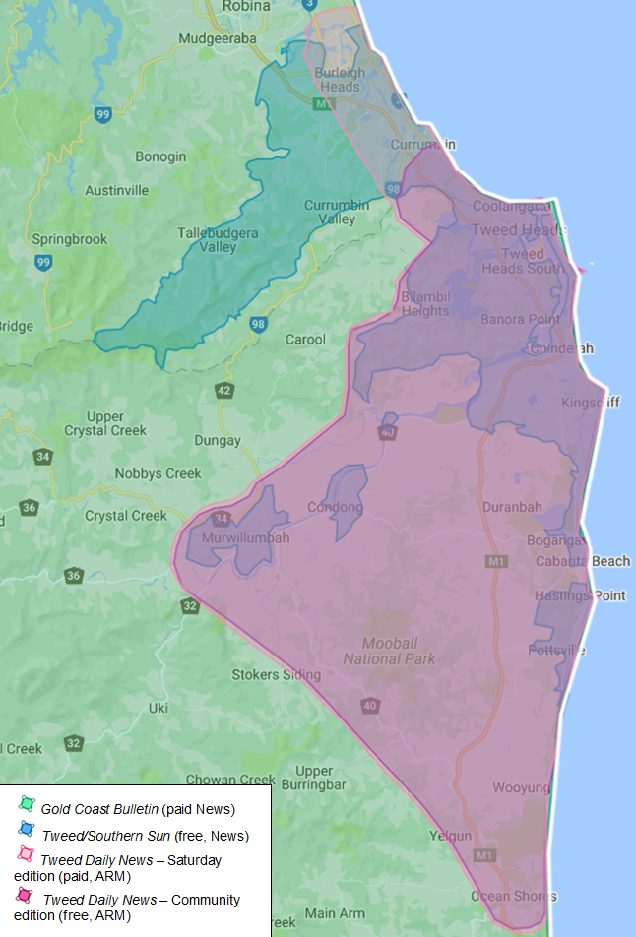
Map source: Google; circulation information obtained from News and ARM websites
- Other potential alternative sources of news in the Tweed Heads/southern Gold Coast area include:
- the following print publications:
  - Tweed Valley Weekly, an independent weekly publication distributed in Tweed Heads and surrounding areas, and associated website tweedvalleyweekly.net.au
  - Byron Shire Echo, an independent free weekly newspaper distributed in neighbouring Byron Shire with a weekly print circulation of 23,200 copies and readership of over 53,000 people, and associated website echo.net.au/byron-echo. While this is a substantial publication, it is focussed on the Byron Shire rather than the Tweed/Gold Coast region.
  - The Friday Flyer, an independent weekly newsletter delivered to homes from Ormeau, Queensland, down to Murwillumbah, New South Wales, and associated website fridayflyer.com.au
- The following websites:
  - MyBT Gold Coast goldcoast.brisbanetimes.com.au (Fairfax)
  - ABC Local – Gold Coast www.abc.net.au/goldcoast
  - ABC Local – North Coast NSW www.abc.net.au/northcoast
- The following radio stations:
  - 4CRB 89.3FM, a community easy-listening station broadcasting to the Gold Coast
  - 720 AM ABC Local Radio North Coast
  - 95.7 FM ABC News Radio Gold Coast
- The ACCC also notes that there is a more limited degree of overlap between News’ and ARM’s publications in the following regions, and would be interested in market feedback as to the extent of this overlap, and any likely effects on competition in these areas:
- Proserpine/Cannonvale/Airlie Beach
- Bowen
- Mackay
- Ipswich
- Byron Bay/Brunswick Heads
The ACCC invites comments from market participants on the following:
- What is the likely impact on reader choice and diversity of news in the local overlap areas if the acquisition proceeds?
- To what extent do the community publications of News and ARM currently compete in the local overlap areas? For example, do you consider that competition between News and ARM improves the quality of content in their newspapers in the local overlap areas?
- If there was a decrease in quality of the News/ARM community publications in the local overlap areas after the acquisition, would consumers be likely to continue reading them? What other sources of local news could consumers turn to if they were dissatisfied with the quality of the newspapers?
- How difficult would it be for someone to start a new local publication in the local overlap areas? For example, if it was a print publication, could they readily access printing services at a reasonable price? How would they promote and distribute the new publication? Would they be able to attract sufficient advertising revenue?

Issue that may raise concerns – reduction in competition in community newspaper advertising in the local overlap areas
- The ACCC’s preliminary view is that the proposed acquisition may be likely to substantially lessen competition in relation to the supply of local advertising opportunities in community (free) print newspapers in each of the local overlap areas, namely:
- Caboolture/Bribie Island
- south west Brisbane
- Brisbane northern bayside
- Logan, and
- Tweed Heads/southern Gold Coast.
- Market inquiries have suggested that there is close competition between News and ARM in offering advertising opportunities in the local overlap areas. Some advertisers stated that competitive pressure between News’ and ARM’s community newspapers has enabled them to secure better advertising deals than would be the case post-acquisition.
- The extent to which other media suppliers would constrain News depends on the type of product or service supplied by the relevant advertiser, its target audience and the purpose of the advertisement (for instance, to raise brand awareness or to publish details of an upcoming sale).
- The ACCC understands that advertising in print community newspapers is attractive to advertisers because it provides the ability to reach a targeted, localised audience. In particular, some advertisers have highlighted the frequency of publication and the distribution areas of community newspapers as key reasons for choosing to advertise in these newspapers.
- A number of advertisers have also indicated that print advertising is still important to their business as a key way of reaching their customers. This is particularly the case in areas where there is an older demographic, who are less likely to access news online, or for more time-sensitive advertisements (such as upcoming sales or events).
- Market inquiries have also suggested that community newspapers are the most effective means of advertising for advertisers in particular categories, such as real estate agents and local retailers. Other forms of advertising, such as pamphlet drops, radio, magazines and metropolitan newspapers, may be effective for some of these advertisers, but not all. For example, advertising in newspapers provides an advertiser with exposure to buyers who may not be actively looking for a good or service, but may decide to purchase after seeing an advertisement. This differs from, for example, online search advertising where the customer is actively searching for a product having already identified a need for or interest in a particular type of product.
- The ACCC is therefore concerned the proposed acquisition may remove a significant source of competitive pressure on News and enable it to increase rates for print advertising in the local overlap areas.
- The ACCC notes that News also has interests in other online classifieds businesses, including:
- a majority stake in REA Group, which owns realestate.com.au,
- minority interests in online automotive classifieds business Carsguide.com.au and online employment classifieds business Careerone.com.au. News has also recently entered into an arrangement to acquire online employment classified advertisements from Seek to resell to advertisers as part of a bundle with News’ print employment advertisements.
- As part of the proposed acquisition, News will also acquire ARM’s classifieds website, finda.com.au.
- If the proposed acquisition is likely to increase News’ market power in the supply of print advertising, News may also be able to leverage this increased market power to affect competition in online classified advertising, for example by engaging in bundling or tying. The ACCC will further consider these issues in the next stage of its review.
The ACCC invites comments from market participants in relation to these issues, including on the following:
- How closely do News and ARM’s community newspapers compete for advertisers in the local overlap areas? For example, do advertisers use the presence of ARM to negotiate lower rates with News (or vice versa)?
- Are there other print publications in the local overlap areas that are a suitable alternative to the News and ARM publications for local advertising? Please identify any such alternatives.
- To what extent do other forms of advertising (including online, TV, radio, billboards, metropolitan newspapers and direct forms of advertising, such as pamphlets) constrain the price of community newspaper advertising? Are there some advertisers that cannot use these other options? If so, who are these advertisers?
- What effect (if any) do you think the proposed acquisition is likely to have on competition in the supply of online classifieds advertising, including real estate, automotive, employment and general, noting the existing interests News has in these areas? Is News likely to engage in increased bundling or tying of print and online advertising products as a result of the proposed acquisition?

Issue unlikely to raise concerns – the supply of advertising opportunities in regional areas of Queensland
- Based on its review to date, the ACCC’s preliminary view is that the proposed acquisition is unlikely to raise competition concerns in relation to the supply of advertising opportunities in regional areas of Queensland, for example Mackay, Rockhampton, Toowoomba and the other areas where ARM currently publishes regional newspapers.
- The ACCC notes that the geographic overlap between The Courier Mail and ARM’s paid regional newspapers means that they are likely to be considered substitutes by some advertisers. For example, an advertiser seeking to run a state-wide advertising campaign might choose between advertising in The Courier Mail or in the ARM regional newspapers when attempting to capture the regional audience.
- However, it appears that:
- the majority of advertisers in regional newspapers do not also advertise in metropolitan or national newspapers, due to the significantly higher advertising costs. This increased cost reflects the broader geographic reach of these newspapers, which is not valued by most local advertisers.
- customers who do advertise in both metropolitan and regional newspapers tend to be large state or national organisations, or businesses represented by large advertising agencies. These advertisers generally have some degree of bargaining power and other options to reach their audience, such as radio and television.
- Considered together, the above factors contributed to the ACCC’s preliminary view that, although there may be “consumer-side” competition issues in the areas where ARM publishes regional newspapers, there are less likely to be “advertiser-side” competition issues. However, the ACCC will further consider this issue in the next stage of its review.
The ACCC invites comments from market participants in relation to this issue, including on the following:
- How closely do News’ The Courier Mail and ARM’s regional newspapers compete for advertisers? For example, do advertisers use the presence of ARM to negotiate lower rates with News (or vice versa)?
- To what extent do other forms of advertising (including online, TV, radio, billboards, and direct forms of advertising, such as pamphlets) constrain the price of advertising in paid newspapers? Are there some advertisers that cannot use these other options? If so, who are these advertisers?
- As with the community newspapers in the local overlap areas, are there likely to be any effects on competition (e.g. increased bundling or tying by News) in the supply of online classifieds advertising (including real estate, automotive, employment and general) in regional areas, noting the existing interests News has in these areas?

Issue unlikely to raise concerns – the acquisition of content from content providers
- As set out in the ACCC’s media merger guidelines, one of the issues that the ACCC typically considers in a media merger is the likely effects on competition in the acquisition of content from content providers.
- In this case, the ACCC understands that most of the local news and information published in News and ARM community newspapers and related online news sites is produced in-house by journalists employed by the publisher.
- In respect of non-local content that may be acquired from third party providers (e.g. newswire services), such as national or international news, TV listings or crosswords, the loss of a single newspaper customer is unlikely to be significant from a competition perspective.
- Accordingly, the ACCC’s preliminary view is that the proposed acquisition is unlikely to raise competition concerns in any relevant market for the acquisition of content from content providers.

ACCC's future steps
- The ACCC will finalise its view on this matter after it considers submissions invited by this Statement of Issues.
- As noted above, the ACCC now seeks submissions from market participants on each of the issues identified in this Statement of Issues and on any other issue that may be relevant to the ACCC's assessment of this matter. Submissions are to be received by the ACCC no later than 27 October 2016 and should be emailed to mergers@accc.gov.au with the subject: Submission re: News/ARM - attention Lisa Campbell/David Wang. If you would like to discuss the matter with ACCC officers over the telephone or in person, or have any questions about this Statement of Issues, please contact Lisa Campbell on (02) 9230 9138 or David Wang on (02) 9230 3819.
- The ACCC intends to publicly announce its final view by 1 December 2016. However the anticipated timeline may change in line with the Informal Merger Review Process Guidelines. A Public Competition Assessment may be published following the ACCC's public announcement, to explain its final view.

Attachment A – List of News and ARM publications in Queensland and northern NSW
Party | Title | Main distribution towns | Price | Frequency | Circulation* | Readership*
North Queensland
ARM | Daily Mercury | Mackay region | Mon-Fri $1.50  Sat $1.80 | Daily, Mon-Sat | Mon-Fri 8,186  Sat 9,243 | Mon-Fri 42,000  Sat 36,000
 | The Midweek | Mackay region | Free | Weekly, Wed | 12,982 | 16,000
 | Whitsunday Times | Airlie Beach, Cannonvale, Proserpine | Free | Weekly, Thu | 7,089 | 14,000
 | Whitsunday Coast Guardian | Cannonvale, Proserpine | $1.10 | Weekly, Wed | 1,530 | 5,000
News | The Courier Mail/The Sunday Mail | Queensland-wide | Mon-Fri $1.50  Sat $2.20  Sun $2.70 | Daily, Mon-Sat, Sun (The Sunday Mail) | Mon-Fri 147,122  Sat 179,149  Sun 318,830 | Mon-Fri 603,000  Sat 589,000  Sun 794,000
 | Townsville Bulletin | Townsville | Mon-Fri $1.40  Sat $2.20 | Daily, Mon-Sat | Mon-Fri 18,194  Sat 25121 | Mon-Fri 89,000  Sat 83,000
 | Cairns Post | Cairns | Mon-Fri $1.40  Sat $2.20 | Daily, Mon-Sat | Mon-Fri 15,790  Sat 27,232 | Mon-Fri 73,000  Sat 79,000
 | Bowen Independent | Bowen (Whitsundays, Burdekin, Collinsville) | $1.20 | Wednesdays and Fridays | 2,635 | N/A
 | Townsville Sun | Townsville | Free | Weekly, Wed | 24,539 | N/A
 | Cairns Sun | Cairns | Free | Weekly, Wed | 25,018 | N/A
 | Tablelands Advertiser | Malanda, Millaa Millaa, Mareeba | $1.20 (free on the Tablelands) | Weekly, Fri | 15,535 | 24,000
 | Tablelander | Malanda, Millaa Millaa, Mareeba | $1.20 (free on the Tablelands) | Weekly, Tues | 15,745 | 29,000
 | Innisfail Advocate | Innisfail |  | Wednesday and Saturday | 3,201 | N/A
 | Port Douglas& Mossman Gazette | Port Douglas, Mossman Gorge | $1.20 | Weekly, Thu | 3,773 | N/A
 | Herbert River Express | Cardwell, Kennedy, Rollingstone, Toomulla | $1.20 | Bi-weekly, Wed and Sat | 2,724 | N/A
 | Northern Miner | Charters Towers | $1.20 | Bi-weekly, Tue and Fri | 2,353 | N/A
 | Advocate | Burdekin | $1.20 | Bi-weekly, Wed and Fri | 14,803 | N/A
Central Queensland
ARM | The Morning Bulletin | Rockhampton | Mon-Fri $1.50  Sat $1.90 | Daily, Mon-Sat | Mon-Fri 9,979  Sat 13,422 | Mon-Fri 39,000  Sat 38,000
 | The Observer | Gladstone | Mon-Fri $1.50  Sat $1.70 | Daily, Mon-Sat | Mon-Fri 4,024  Sat – 5,194 | Mon-Fri 21,000  Sat - 18,000
 | Capricorn Coast Mirror | Capricorn Coast and surrounding regions (including Rockhampton, Yeppoon) | Free | Weekly, Wed | 11,566 | 13,000
 | Central Telegraph | Biloela | $1.50 | Weekly, Fri | 2,318 | 8,000
 | Central Queensland News | Emerald, Barcaldine | $1.50 | Weekly, Fri | 2,758 | 12,000
News | The Courier Mail | As above
Wide Bay Burnett
ARM | NewsMail | Bundaberg | Mon-Fri $1.50  Sat $1.90 | Daily, Mon-Sat | Mon-Fri 6,684  Sat 10,316 | Mon-Fri 33,000  Sat 34,000
 | Fraser Coast Chronicle | Hervey Bay, Maryborough | Mon-Fri $1.50  Sat $1.60 | Daily, Mon-Sat | Mon-Fri 6,218  Sat 6,338 | Mon-Fri 33,000  Sat 26,000
 | The Gympie Times | Gympie | Tue-Fri $1.50  Sat $1.70 | Daily, Tue-Sat | Tue-Fri 3,409  Sat 5,768 | Tue-Fri 19,000  Sat 17,000
 | Guardian | Bundaberg | Free | Weekly. Wed | 21,931 | 13,000
 | Isis Town & Country | Childers | $1.50 | Weekly, Thu | 1,175 | N/A
 | Central & North Burnett Times | Biggenden, Gayndah, Mundubbera, Mt Perry, Eidsvold, Monto | $1.50 | Weekly, Thu | 2,275 | 7,000
 | Hervey Bay Observer | Hervey Bay | Free | Weekly, Thu | 22,601 | 26,000
 | The Maryborough Herald | Maryborough | Free | Weekly, Thu | 12,074 | 14,000
 | Cooloola Advertiser | Cooloola | Free | Weekly, Tue | 7,603 | N/A
 | Hervey Bay Independent | Hervey Bay | Free | Weekly, Tue | 22,000 | N/A
News | The Courier Mail | As above
Sunshine Coast
ARM | Sunshine Coast Daily | Sunshine Coast | Mon-Fri $1.50  Sat $2.00 | Daily, Mon-Sat | Mon-Fri 11,309  Sat 15,248 | Mon-Fri 64,000  Sat 57,000
 | Sunshine Coast Sunday | Sunshine Coast | $1.60 | Weekly, Sun | N/A | N/A
 | Noosa News | Noosa | Free | Bi-weekly, Tue and Fri | 24,308 | 32,000
 | Coolum & North Shore News | Coolum | Free | Weekly, Fri | 12,507 | 16,000
 | Maroochy Weekly | Maroochydore | Free | Weekly, Thu | 15,300 | 11,000
 | Kawana Weekly | Kawana | Free | Weekly, Thu | 10,038 | 11,000
 | Caloundra Weekly | Caloundra | Free | Weekly, Thu | 18,950 | 23,000
 | Nambour Weekly | Nambour | Free | Weekly, Thu | 11,030 | 13,000
 | Buderim Chronicle | Buderim | Free | Weekly, Thu | 16,340 | 18,000
News | The Courier Mail | As above
South East Queensland (Greater Brisbane and Ipswich)
ARM | The Queensland Times | Ipswich | Mon-Fri $1.50  Sat $1.90 | Daily, Mon-Sat | Mon-Fri 6,746  Sat 8,256 | Mon-Fri 36,000  Sat 32,000
 | Caboolture News | Caboolture | Free | Weekly, Wed | 33,710 | 44,000
 | Bribie Weekly | Bribie Island | Free | Weekly, Fri | 12,540 | 17,000
 | The Logan Reporter | Logan | Free | Weekly, Fri | 51,187 | 39,000
 | The Satellite | Springfield, Redbank | Free | Weekly, Wed | 42,361 | 35,000
 | The Ipswich Advertiser | Ipswich | Free | Weekly, Wed | 34,173 | 28,000
 | Bayside and Northern Suburbs Star | Sandgate | Free | Weekly, Wed | 37,453 | N/A
News | The Courier Mail | As above
 | Albert and Logan News | Logan | Free | Weekly, Thurs | 74,451 | 74,000
 | Caboolture Herald | Caboolture | Free | Weekly, Thurs | 37,741 | 44,000
 | Pine Rivers Press/ North Lakes Times | Pine Rivers and North Lakes areas | Free | Weekly, Thurs | 38,260 | 42,000
 | Redcliffe & Bayside Herald | Redcliffe | Free | Weekly, Wed | 34,168 | 47,000
 | City North News | Northern metropolitan Brisbane | Free | Weekly, Thurs | 28,838 | 14,000
 | North-West News | Bunya, Ferry Grove, Mitchelton, Newmarket | Free | Weekly, Wed | 42,854 | 49,000
 | Northside Chronicle | Brisbane northern bayside | Free | Weekly, Wed | 62,162 | 67,000
 | Westside News | West Brisbane (including Ashgrove, Kenmore and Red Hill) | Free | Weekly, Wed | 56,081 | 37,000
 | South-West News/ Springfield News | South west metropolitan Brisbane and the grater Springfield area | Free | Weekly, Wed | 55,028 | 45,000
 | City South News | Southern metropolitan Brisbane | Free | Weekly, Thurs | 27,337 | 15,000
 | South East Advertiser | South east metropolitan Brisbane | Free | Weekly, Wed | 49,376 | 46,000
 | Southern Star | Southern Brisbane (including Upper Mount Gravatt and Sunnybank and Acacia Bridge) | Free | Weekly, Wed | 59,293 | 52,000
 | Wynnum Herald | Wynnum and Manly | Free | Weekly, Wed | 33,337 | 42,000
 | Brisbane News | Inner Brisbane | Free | Wednesday | 100,000 | 108,000
South West Queensland
ARM | Stanthorpe Border Post | Stanthorpe | $1.50 | Bi-weekly, Tue and Thu | 1,743 | 5,000
 | Warwick Daily News | Warwick | Mon-Fri $1.50  Sat $1.70 | Daily, Mon-Sat | Mon-Fri 2,407  Sat 2,347 | Mon-Fri 9,000  Sat 7,000
 | Dalby Herald | Dalby | $1.50 | Bi-weekly, Tue and Fri | 1,915 | 7,000
 | Gatton, Lockyer and Brisbane Valley Star | Gatton, Laidley, Esk | Free | Weekly, Wed | 19,771 | 30,000
 | Laidley Plainland Leader | Laidley, Plainland | Free | Monthly, Fri | 7,045 | N/A
 | South Burnett Times | Kingaroy | $1.50 | Bi-weekly, Tue and Fri | 4,397 | 15,000
 | Southern Downs Weekly | Warwick, Killarney, Allora, Stanthorpe | Free | Weekly, Wed | 11,869 | 12,000
 | Balonne Beacon | St George and the Balonne Shire | $1.50 | Weekly, Thu | 1,075 | 3,000
 | The Western Star | Roma | $1.50 | Bi-weekly, Tue and Fri | 1,972 | 7,000
 | Western Times | Charleville, Cunnamulla | $1.50 | Weekly, Thu | 1,238 | 3,000
 | Chinchilla News and Murilla Advertiser | Chinchilla, Miles, Tara and Taroom | $1.50 | Weekly, Thu | 3,029 | 11,000
 | The Chronicle | Toowoomba | Mon-Fri $1.50  Sat $2.00 | Daily, Mon-Sat | Mon-Fri 15,365  Sat 20,044 | Mon-Fri 58,000  Sat 59,000
News | The Courier Mail | As above
Gold Coast/northern NSW
ARM | Tweed Daily News | Tweed Heads | $2.00 | Weekly, Sat | 2,660 | 13,000
 | The Northern Star | Brisbane northern Bayside | Mon-Fri $1.50  Sat $2.00 | Daily, Mon-Sat | Mon-Fri 7,870  Sat 12,676 | Mon-Fri 38,000  Sat 38,000
 | The Daily Examiner | Grafton | Mon-Fri $1.50  Sat $1.50 | Daily, Mon-Sat | Mon-Fri 3,616  Sat 3,913 | Mon-Fri 16,000  Sat 14,000
 | The Woolgoolga Advertiser | Woolgoolga and the Northern Beaches | Free | Weekly, Sat | 5,732 | N/A
 | Tweed Daily News – Community Edition | Tweed Heads | Free | Weekly, Wed | 26,968 | 26,000
 | Byron Shire News | Byron Bay | Free | Weekly, Thu | 15,885 | 16,000
 | Ballina Shire Advocate | Ballina | Free | Weekly, Wed | 16,359 | 21,000
 | Lismore Echo | Lismore | Free | Weekly, Thu | 17,921 | 37,000
 | The Richmond River Express Examiner | Richmond Valley | Free | Weekly, Wed | 13,596 | 16,000
 | Coastal Views | Clarence Valley incl Grafton, Cowper, Maclean | Free | Weekly, Fri | 10,819 | 13,000
 | The Coffs Coast Advocate | Clarence Valley | Free | Weekly, Wed and Sat | 30,691 | 48,000
News | The Courier Mail | As above
 | Gold Coast Sun Upper North | Upper Gold Coast (including Ormeau and Helensvale) | Free | Weekly, Wed | N/A | N/A
 | Gold Coast Sun North | North Gold Coast (including Main Beach) | Free | Weekly, Wed | N/A | N/A
 | Gold Coast Sun Central | Central Gold Coast (including Advancetown) | Free | Weekly, Wed | N/A | N/A
 | Gold Coast Sun Tweed / Southern | Tweed Heads | Free | Weekly, Thurs | N/A | N/A
 | Gold Coast Bulletin | Gold Coast region | Mon-Fri $1.40  Sat $2.20 | Daily, Mon-Sat | Mon-Fri 24,711  Sat 32,010 | Mon-Fri 109,000  Sat 104,000
* Sources: emmaTM conducted by Ipsos MediaCT, 12 months ending March 2016. CAB, March 2016 included on http://www.newscorpaustralia.com/our-brands and http://apnarm.com.au/print/

ARM also publishes paid non-daily newspapers in the following areas: Whitsundays; Biloela and surrounds; Emerald, Barcaldine and surrounds; Childers and surrounds; Biggenden and surrounds; Stanthorpe; Dalby; Kingaroy and surrounds; the St George region; Roma; Charleville, Cunnamulla and surrounds; Chinchilla and Tweed Heads.
News announced that it would be selling this interest in late 2016.
A list of Fairfax’s publications is available at http://www.fairfaxmedia.com.au/portfolio-landing
For example, a “grand opening sale tomorrow” advert could not be effectively placed in a magazine distributed monthly.
There is also some overlap between The Courier Mail and ARM’s paid, non-daily (i.e. weekly or bi-weekly) newspapers, which are published in the Whitsundays; Biloela and surrounds; Emerald, Barcaldine and surrounds; Childers and surrounds; Biggenden and surrounds; Stanthorpe; Dalby; Kingaroy and surrounds; the St George region; Roma; Charleville, Cunnamulla and surrounds; Chinchilla and Tweed Heads.
Independent News & Media is a media organisation based in Dublin, Ireland.
Jimboomba Times is distributed to Jimboomba to Cedar Grove, Cedar Vale, Flagstone, Tamborine, Logan Village, Buccan, Park Ridge, Teviot, New Beith, Greenbank, Spring Mountain, Maclean, Munruben, Chambers Flat, Reimore Downs, Mundoolun Estate, Collins Estate, Echo Valley and Munruben Woods.
Redland City Bulletin is distributed to Greenbank, Park Ridge South, Logan Reserve, Munruben, Chambers Flat, Buccan, Logan Village, Maclean, Jimboomba, Flagstone, Cedar Vale, Cedar Grove and Tarrabiba.
This includes both the current “Media Mergers’ guidelines published in 2006 and the revised draft ‘Media Merger Guidelines’ released for public consultation in August 2016.

