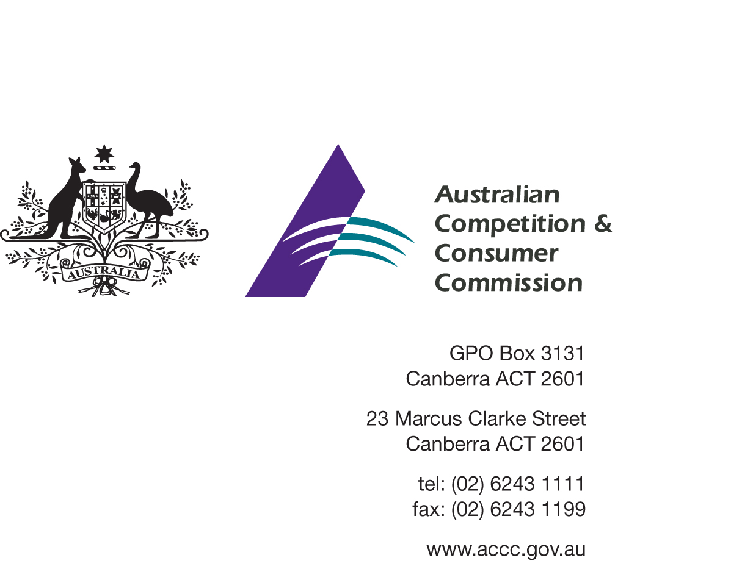

DISCUSSION PAPER

Review of the Consumer Product Safety Standard for Bunk beds
This discussion paper details policy proposals under consideration in the review of the mandatory standard for bunk beds

August 2014
Closing date for submissions 15 September 2014

Australian Competition and Consumer Commission
23 Marcus Clarke Street, Canberra, Australian Capital Territory, 2601

© Commonwealth of Australia 2013

This work is copyright. In addition to any use permitted under the Copyright Act 1968, all material contained within this work is provided under a Creative Commons Attribution 3.0 Australia licence, with the exception of:

- the Commonwealth Coat of Arms
- the ACCC logo
- any illustration, diagram, photograph or graphic over which the Australian Competition and Consumer Commission does not hold copyright, but which may be part of or contained within this publication.

The details of the relevant licence conditions are available on the Creative Commons website, as is the full legal code for the CC BY 3.0 AU licence.

Requests and inquiries concerning reproduction and rights should be addressed to the Director, Corporate Communications, ACCC, GPO Box 3131, Canberra ACT 2601, or publishing.unit@accc.gov.au.

Important Notice

The information in this publication is for general guidance only. It does not constitute legal or other professional advice, and should not be relied on as a statement of the law in any jurisdiction. Because it is intended only as a general guide, it may contain generalisations. You should obtain professional advice if you have any specific concern.

The ACCC has made every reasonable effort to provide current and accurate information, but it does not make any guarantees regarding the accuracy, currency or completeness of that information.
Parties who wish to re-publish or otherwise use the information in this publication must check this information for currency and accuracy prior to publication. This should be done prior to each publication edition, as ACCC guidance and relevant transitional legislation frequently change. Any queries parties have should be addressed to the Director, Corporate Communications, ACCC, GPO Box 3131, Canberra ACT 2601, or publishing.unit@accc.gov.au.

Contents
Purpose 4
Summary 4
Consultation 5
Background 6
The Australian consumer product safety system 6
The current mandatory standard 6
Hazards addressed by the current standard 6
Market trends and product use 7
Compliance 8
Product recalls 8
Enforcement actions 8
Injury data 8
Victorian injury data 9
Queensland data 9
Overseas data 10
Queensland coroner’s report and implications for the commercial market 11
Is the continuation of regulatory intervention justified? Error! Bookmark not defined.
Proposed amendments to the mandatory standard 11
Revise the definition of a bunk bed 13
Mattress base and support strength 13
Hazardous gaps (entrapment) issues 14
Access issue 15
Instructional Information- correct assembly and safe use 15
Guard rail height 16
Guard rail stability 16
Number of access openings 16
Minimum recommended age for bunk bed use 17
Conclusion 17
Appendix A - Summary of Options and Hub Questions 18
Appendix B - Examples of themed bunks and elevated beds 20
Appendix C - Product Recalls - summary 23
Appendix D - Recent Enforcement Actions - Summary 24

Purpose
The purpose of this paper is to consult with stakeholders on the current consumer product safety standard for the supply of bunk beds in Australia- Consumer Protection Notice No.1 of 2003 (the Standard) which references the Australian Standard AS/NZS 4220:1994 and on proposed changes to the Standard.
This paper seeks relevant information and views from interested parties that will assist in determining the optimal approach for the future regulation of bunk beds under the Competition and Consumer Act 2010 (the CCA). Of particular interest is any evidence which will assist in assessing the potential impacts and benefits of each of the regulatory changes.

This paper may provide the only opportunity for stakeholders to provide their input into the review process and all interested parties are encouraged to make submissions on the options or other issues relevant to the review even if they agree with the options set out below.

Summary
This paper reviews the Standard, levels of supplier compliance, various product issues and relevant injury data. It:

- explores whether regulation of bunk beds continues to be justified
- describes possible changes to the standard
- seeks stakeholder feedback on these changes
- seeks information to assist in the development of any revised regulation
- seeks information on potential impacts of the proposed changes

The Standard is based on a voluntary standard from 1994 – the Australian and New Zealand standard AS/NZS 4220 (the voluntary standard). The discussion paper proposes that certain essential safety elements of the most recent 2010 version the voluntary standard be adopted. These changes are focussed on addressing emerging hazards and further increasing the safety of bunk and elevated beds.

Please note: the complete wording of all clauses being referenced from the voluntary standard is not replicated in this paper. The full text of the voluntary standard can be obtained from SAI Global at www.saiglobal.com.au.

It is timely that the Standard be reviewed now, given the industry and market developments in the design of bunk beds and changes in product use since its introduction. In addition a number of changes have been made in the voluntary standard since 1994 to address various hazards not considered at that time.

Bunk beds supplied by the industry around the time the voluntary standard was originally developed typically consisted of simple, wooden or metal constructions of a basic or uniform size, shape and function. The current product range supplied by industry is more diverse and designed with various styles and features which create different market demands and potentially involve new safety issues with their use.

This paper proposes that the Standard continues and is amended. The ACCC’s understanding is that the industry supplying bunk beds accepts and supports the need for continuing regulation and for a mandatory standard which regulates certain aspects of the product’s design and performance.

Removal of the Standard was considered but is not recommended. The ACCC considers that minimum safety requirements are reasonably necessary to continue to reduce the level and risk of injury to children when using bunks or elevated beds.

If a revised Standard is the outcome of this review and consultation process, bunks and elevated beds sold after a specified date must comply with the new mandatory standard. It is expected that a lead time of between 12-18 months will be operative to allow suppliers to make any necessary changes.

Consultation
Stakeholders are invited to make submissions on the proposals set out in this paper. The closing date for feedback is 15 September 2014.
You are encouraged to provide feedback by completing the online questionnaire at the ACCC Consultation Hub. Completing the online questionnaire is the preferred way to provide feedback, though we also welcome written submissions. The form at Appendix A provides details of the proposed changes and can also be used to provide feedback. Any additional feedback would also be welcome.
Submissions can be emailed to:
Email: productsafety.regulation@accc.gov.au
Subject: Bunk bed standard review
Alternatively you may mail your response to:
Director
Standards and Compliance (Children’s and Household Products)
Product Safety Branch
GPO Box 520
Melbourne VIC 3001
If you consider that any of the information you provide is confidential, sensitive or Commercial in Confidence, please clearly indicate this on the documentation. If the information provided is of a confidential nature, you can be assured that the details provided by you will be treated confidentially. That is, the ACCC will not disclose the confidential information to third parties, other than advisors or consultants engaged directly by the ACCC, without first providing you with notice of its intention to do so, such as where it is compelled to do so by law.

The ACCC may be compelled by law to disclose submissions (for example under subpoena or following a request under the Freedom of Information Act 1982). For more information see the ACCC-AER Information Policy available via www.accc.gov.au

Background

The Australian consumer product safety system
Section 105 (1) of the Australian Consumer Law (ACL) allows the Commonwealth Minister to declare an Australian Standard either in whole or part, with additions or variations, to be a safety standard for consumer goods.
Section 104 of the ACL allows the Commonwealth Minister to make a safety standard for consumer goods which sets out requirements for those consumer goods which are reasonably necessary to prevent or reduce the risk of injury to any person. Safety standards made under the ACL are co-operatively enforced by the ACCC and state and territory fair trading agencies.
Section 106 of the ACL states that a person must not in trade or commerce, supply, offer for supply or manufacture for supply, consumer goods of a particular kind if those goods do not comply with a safety standard currently in force for those goods.
A safety standard for bunk beds regulates the supply of bunk beds. The term ‘supply’ in relation to consumer goods (such as bunk beds) means to supply by way of sale, exchange, lease, hire or hire-purchase.

The current mandatory standard
The Standard for bunk beds first came into effect on 1 November 2002 and is based on the voluntary standard. The Standard was introduced in response to the level of injury consistently occurring to children using bunks in various State jurisdictions.
In March 2003 the Standard was revised to exclude bunks in caravans, bunks in other vehicles and bunks used for camping purposes, as injury data did not appear to warrant their inclusion.
A bunk bed is defined by the Standard as either:
- A set of components that are assembled or are ready for assembly into single beds or double single combination beds, which will be stacked one over the other; or
- Any single bed other than a hospital bed where the upper surface of the mattress base is at least 800mm above the floor surface.
The mandatory standard sets minimum construction, safety and performance requirements for bunks and elevated beds, in particular requiring that effective guard rails be provided around all sides of the upper bunk or elevated bed and that no hazardous or entrapment gaps or protrusions were present in the bunk’s design or construction.
The mandatory standard also includes requirements for markings in relation to supplier identification and maximum mattress height. It does not include references to the recommended age group for using bunk beds.

Hazards addressed by the current standard
The potential hazards which are addressed by the Standard are:
- asphyxiation or strangulation from head or neck entrapments in gaps large enough for a child’s feet or body but not large enough for the passage of a child’s head
- falls (over or through guard rails) from the upper bunk
- strangulation or choking caused by an item of a child’s clothing snagging on upper bunk protrusions
- falls through the bunk as a result of weak or insufficiently secured upper bunk mattress base members or supports.
The overwhelming majority of injuries that occur to children are as a result of falls from the bunk bed.

Market trends and product use
The design, purpose and use of bunk beds has changed significantly since the voluntary standard referenced in the Standard was first published in 1994 and further still since the Standard became operational in 2003. This voluntary standard has since been significantly revised twice.
In that time, innovation in bunk bed design has resulted in more complex and multi-functional products. Bunk beds are often supplied as integrated sleeping areas and are designed to incorporate various other functions and activities which may involve elements of study or storage, or encourage play and activity for children, particularly with themed products which appeal to and attract the attention of very young children. Examples of some of these, such as vehicles, forts, and bunks with sporting themes are shown at Appendix B.
There has also been a market trend to supply more elevated beds, including beds designed with a mattress base that is below the height at which the product is classified as a bunk and therefore not currently subject to regulation.
Bunks are a viable, alternative sleeping product for families with more than one child or in homes where there is a restriction on available space and bedroom options. As a significant and prominent item of furniture, bunk beds are designed to have a relatively long product life and they may potentially be used by many children during this time.

A national survey commissioned by the ACCC in October 2012 indicates that approximately one in three households with young children have a bunk or elevated bed in the home. Of these, around 75% of the families had used the bunk or elevated bed for sleeping children aged 8 and under.

An organisation involved in testing and certifying bunk bed compliance with the standard, (Furntech, the Australasian Furnishing Research and Development Institute, an independent, not-for-profit technical organisation that provides standards, testing, product certification and research for buyers and sellers of furniture), has made representations to the ACCC that it has observed the following product developments and possible related hazards for bunk beds:

- Bunk bed designs which introduce elements of play, study, storage. Products which incorporate drawers and storage facilities in upper bunk access steps, as well as being designed with certain play facilities or features readily attractive to young children and encourage them to play on or around the product.

- Bunks which provide different methods of access, including the provision of access stairs with drawers underneath the steps
- Bunks where the stability and strength of guard rails and access devices is questionable. Whilst the provision of safety rails around the upper bunk are required by the regulation, the rails provided are currently not required to be subjected to a level of applied force which replicates conditions during actual use. Guard rail strength and attachment to the upper bunk has become a safety issue in certain products
- The quality and strength of mattress base supports. Products are not required to provide supports which meet a requirement to resist forces or weight replicating actual use. This has also become a safety issue recognised in certain products.
- Access devices, ladder suitability. Some products are supplied without a dedicated access device (ladder) which encourages children to climb some part of the frame to the upper bunk or have ladders which are not sufficiently secure or strong.

Compliance
ACCC monitoring of industry and the market indicates moderate to high levels of compliance with the Standard’s key safety design aspects, although a moderate to low level of compliance with the marking requirements.Non compliance is evidenced by:

- ACCC Market surveillance –in 2013, 71 bunks across 33 stores were surveyed of which 19 were non-compliant with 17 of these missing supplier details

Product recalls-Products which are identified by the ACCC in its product surveillance activities have been withdrawn from supply where non-compliance with the standard has been found. Since 1998 there have been recalls of 40 different models of bunks from 22 separate bunk bed suppliers listed on the Recalls Australia website (www.recalls.gov.au). These recalls include five models in 2009, two in 2010, nine in 2011, 5 in 2012 and two in 2013. Issues which have generated recall actions have included products which have incomplete guard rails, have included potential protrusions and snag points, hazardous gaps and openings which have been too large, inadequate rail height, or a lack of mattress height markings and importers identification. A list of recalled bunks is included as Appendix C.

Enforcement actions- The ACCC has investigated the supply of several bunk beds as the result of surveillance and complaints since the introduction of the Standard. Non-compliance has been detected with gaps in guard rails, protrusions on corner posts, mattress supports not being secured or prone to collapse, entrapment hazards and roll out hazards.

A summary of some recent enforcement actions with respect to suppliers of non-compliant bunk beds which have resulted in court enforceable undertakings is included as Appendix D. The ACCC will continue to actively monitor the supply of bunk beds for compliance with the Standard and will take enforcement action wherever necessary.

Positive compliance outcomes have been achieved through the existing requirements of the Standard with recalls and enforcement actions but further enhancements are necessary in order to keep pace with changes in product design. Issues such as the strength of guard rails and mattress supports have not been addressed in the Standard to date

Injury data
Injury data collected on bunks and elevated beds consistently indicate that falls from bunks remain the most significant mechanism of injury, particularly for young children, with almost half of the injuries occurring to children between the ages of 5 and 9.

A recent (Autumn 2013) edition of the Victorian Injury Surveillance Unit’s Hazard publication indicated that falling is the leading cause of injury hospitalisation among children in Victoria and confirmed fall injuries as the most common type of bunk bed injury.

Victorian injury data
The latest injury data obtained from the Victorian Injury Surveillance Unit (VISU) indicates that over the five year period from July 2006 to June 2011, there were 1491 bunk bed related presentations to Victorian hospitals (362 admissions and 1129 emergency department presentations).
Of the presentations, 87% were fall related injuries and 56% were children 0-6 years old, with 35% being children aged 2 to 4 years. Of the 362 admissions to Victorian hospitals, almost 60% were for children aged 6 and under.
Information obtained from VISU on presentations to emergency departments of 37 hospitals participating in the Victorian Emergency Minimum Dataset (VEMD) from January to December 2007 indicates that:
- there were 277 bunk bed related presentations to participating hospitals (an average to 23 per month, or more than five per week)
  - of these, 91% (252) were from falls, including jumping from the bunk
  - of the 246 domestic injury cases, 203 (83%) of them were of children in the 0-9 age group, 110 (45%) in the 0-4 group, 93 (38%) in the 5-9 group and 157 of these (64%) resulted in head, face or neck injury, or injuries to upper extremities.

Queensland data
The most recent data provided through the Queensland Injury Surveillance Unit (QISU) for 2004-2011 indicates that there were 1564 bunk bed related presentations to hospital emergency departments in Queensland over the seven year period, averaging almost 300 per annum in recent years. Around 85% of all presentations over the period were of children 9 and under, with 65% relating to children aged six years and under. The median age for presentations was five years.
Falls accounted for most injuries (76%) whilst ‘hit by ceiling fan’ accounted for 14%. The most frequently injured body region was the head (55%).
Bunk bed admissions averaged around 94 cases per annum (again the median age was five years for these admissions).
QISU previously generated a detailed statistical analysis of bunk bed related injuries in that state. Data collected by QISU from several hospitals in areas representing one quarter of the total Queensland population over a nine year period (from 1999 – 2007) indicated that 1020 bunk bed related injuries were reported.
This generated an actual annual rate of 113 injury presentations per annum across the survey population (or an estimate of around 450 per annum if extrapolated to the whole of the state’s population).
Of the total injury presentations of 1020 in the 1999-2007 Queensland study:
- 95% (969) occurred in the private home
- 98% (997) were to children aged 14 or younger
- 86% (877) were to children aged 9 and under
- 40% (408) were to children aged 1 to 4
- 85% (864) were the results of ‘falls’
- 20% (208) resulted in admission or transfer of the patient to acute care facilities for observation or injury management.
Two Queensland deaths related to bunk beds were also recorded during this period. The first, in 2002, involved a fall from an unguarded bunk. The second, also occurring in 2002, involved a child being strangled after their head became trapped in a railing. Both of these cases involved bunks in holiday accommodation—one in a caravan and one in a rental property.
Findings published in a report published by the Centre for Accident Research and Road Safety–Queensland early in 2013 indicated that:
- Falls from bunk beds are potentially serious and guard rails, even where properly installed, will not necessarily reduce falls from play or adventure or prevent children from jumping off the top bunk
- After the Standard was introduced in 2003 there was a noticeable drop in the rate (per 1000 injury related Emergency Department presentations) of injuries in the 4-9 year age group age groups from 2004 to 2006
- 76% of ED presentations in the report study period were as a result of ‘falls’ (This was higher still if the two categories of ‘jumping from bunk’ and ‘pushed from bunk’ were also included)
- The median age of children admitted to hospital was 5 years old
Injury data for bunks indicates that children too young to safely use the product are significantly over represented in injury numbers. Safety advice and information consistently provided by product safety organisations as a strategy to discourage use by children at too early an age, appears to have had only a marginal impact on actual usage rates. The issues of safe use, appropriate age and regulatory options are raised later in this paper.

Overseas data
Recent research published in the United States (US) which reviewed American injury data from 2001-2004 estimates that 23 000 children aged 0–9 years were treated annually in emergency departments for bunk bed fall-related injuries, including 14 600 children aged under 6 years. Overall, 3.2% were hospitalised. The injuries sustained were largely fractures, lacerations, contusions and abrasions, and internal injuries, with 25.2% injured in a fall from the top bunk. The most commonly injured body region was the head and neck.
Further detailed US research, which reviewed injury data from 1990 to 2005, reveals that:
- the mean age for patients was 6.8 years;
- the numbers of injuries sustained were highest for the 3-5 year old age group; almost half the children injured (49.6%) were younger than 6 years old;
- falls were the most common mechanism of injury (72.5%);
- the head, neck and facial areas were the most frequently injured body parts (53.3%).
This study also indicates that it would have underestimated the total number of bunk bed related injuries, as only injuries to patients treated in emergency departments were included in these results, rather than presentations to GPs, or incidents not requiring further action.
Overall injury data indicates that although injuries directly related to fundamental design faults with the product are likely to have been favourably impacted by regulation of design and performance, further regulatory focus on construction issues and ongoing attention to safe use are required to ensure that the incidence of injury is minimised. As falls from bunks remain the most significant mechanism of injury and are largely behavioural in nature, there are limits on the response that can be made in a regulatory sense based on product design. Nonetheless, enhancing the structural integrity of bunks, capturing elevated beds as bunks and providing safe use guidance can contribute to a safer outcome.

Queensland coroner’s report and implications for the commercial market
Following a coronial investigation into a bunk bed related death in Queensland in 2008, both the Queensland Coroner and the Queensland Injury Surveillance Unit (QISU) made a number of recommendations.
Amongst other things the Coroner suggested that:
- warnings should be provided on bunk beds about the risk of injury. If a suitable age for safe use of the product cannot be recommended, then it should warn against the use of bunks by children under 14
- consideration should be given to government funded programs to remove bunks that may not meet the standard from private residences
- bunks used in governmental establishments should be made to comply with the Standard and that it should eventually be applied to the commercial environment.
QISU supported the removal of unsafe bunks in both private and rental accommodation.
The Coroner and QISU also recommended separate education campaigns aimed at the domestic market and the rental/accommodation markets respectively. An assessment of the general safety of bunks in a number of Queensland Government commercial establishments was conducted.
Since 21 October 2013, all bunk beds in short term rental accommodation in Queensland must meet mandatory safety standards, regardless of when they were purchased.

Is the continuation of regulatory intervention justified?
The ACCC considers that the regulation of the supply of bunk beds remains justified at this time.
Current injury data continues to indicate that the level of fall injuries is persistent, despite some decline or arresting of the upward injury trend following the introduction of the mandatory standard. This in combination with information of new design features and evidence of usage patterns for bunks continues to present safety hazards.
These factors, together with high compliance levels, justify continued regulation of bunk bed products in order to address hazards associated with:
- the use of bunks by young children and the sustained level of injuries as a result of falls
- the availability of bunk beds as an item which is made attractive for children, encouraging their use
- issues with strength, integrity and access in some bunks and elevated beds
A range of factors have been in operation since the commencement of Standard, including two significant updates to the voluntary standard, as well as the emerging design trends in bunk bed configurations and elevated beds. This suggests that the Standard needs to be updated to continue to be effective. Specifically:
- there are issues which have arisen since the introduction of the Standard with definitions and interpretations, including issues such as the application of the current hazardous gap/entrapment requirements, which make hazard identification and compliance difficult
- there have been some significant design/industry trends over recent years which have lead to new identifiable, emerging hazards not properly captured by the existing mandatory standard
- the way in which bunk beds are marketed or used is significantly different from those which applied in the past.
The ACCC has considered whether this regulation should be repealed. Its preliminary view is that the Standard remains necessary given the vulnerable users of the products and the overall net benefit of the regulation. It has also considered an alternative approach of leaving the current bunk bed regulation unchanged and addressing remaining hazards purely by other means such as educational campaigns. This is not recommended by the ACCC given that these hazards are technical in nature and cannot be addressed by consumer information strategies.

Proposed amendments to the mandatory standard
The discussion paper proposes several possible amendments to the mandatory standard, based on the premise that regulatory intervention continues to be justified, but that amendment is reasonably necessary to continue to prevent or reduce risk of injury to any person. The proposed amendments and a table for submission feedback is provided at Appendix A.

In summary, proposed changes adopt essential safety provisions from the current voluntary standard to:
- revise the definition of ‘bunk bed’
- include new requirements for mattress base supports (or slats)
- revise the requirements designed to mitigate hazardous entrapment gaps and extend them to address the potential for hazardous gaps in access devices such as ladders to the top bunk
- include a new requirement to provide a designated access device (such as a ladder) to access the top bunk
- include a new requirement that safety information be provided with a bunk bed
- clarify the requirement related to guard rail height in line with a revision in the voluntary standard
- update the test for guard rail stability by increasing the force from 100N to 500N in line with a revised force application in the voluntary standard
- include a new requirement related to the maximum number of access openings.

The ACCC also seeks stakeholder views on whether a warning label or other information specifying a minimum recommended age for using bunk beds is warranted.

Each of the proposed amendments is explained in more detail below:

Revise the definition of a bunk bed
It is proposed that the definition of a bunk bed be amended to align with the definition in the voluntary 2010 standard:
3.3 Bunk bed and elevated bed
3.3.1 Bunk bed
A set of components that is or can be assembled as beds, one stacked over the other (see Figure 1); or
3.3.2 Elevated bed
Any elevated bed, other than a hospital bed, in which the upper surface of any mattress base is 700mm or higher above the floor surface.
This amendment will bring into the scope of the Standard elevated or high riser beds which are under the currently prescribed 800mm requirement. These products have been identified through market surveillance and by Furntech as generating similar fall hazards as bunks currently captured by the Standard.

Mattress base and support strength
In order to reduce the potential hazard associated with poorly secured mattress base supports which may be loose or can be moved to the point where they may collapse, it is proposed to include clause 5.6 of AS/NZS 4220: 2010 in the revised mandatory standard. This would be a new requirement in the Standard and would be stated as:
5.6 Mattress support elements (mattress base components)
All components of the bunk bed which are used to support or constrain a mattress shall be so fixed that they shall not be capable of lateral or vertical movement by more than 5mm from their intended positions at joints or fixing points under the application of a force of 500 N in any direction.
NOTE: The purpose of this requirement is to ensure that mattress supports such as slats cannot be slid or lifted out of place.
The strength and integrity of the supports or cross members on which the upper bunk mattress rests is considered an important element of the safe and active use of a bunk or elevated bed.
In the Standard, the only requirement for bunk bed mattress base supports is that there must be a maximum allowable width between mattress base members of 100mm to protect against entrapment or fall through. This existing requirement in the Standard only addresses hazardous gaps whereas the proposed requirement provides for a minimum level of strength of the mattress base to reduce the chance of upper bunk occupants falling through a collapsing or broken base support member.

Hazardous gaps (entrapment) issues
The ACCC has become aware of some interpretation issues for the Standard provisions about potentially hazardous gaps and possible entrapment, fall through or rollout dangers.
The Standard currently addresses the issue of dangerous gaps through three related clauses:
- a clause relating to safety barriers-
  - 6.4.2 (f): which relates to gaps 600mm above the floor surface and formed in the guard rail or by the guard rail and any other component (these can be greater than 230mm but not 400mm when measured in any direction).
- a clause relating to large gaps-
  - 6.4.3: which allows gaps greater than 400mm above the upper bed or between bed ends of the lower and upper bed, the lower bed guard rail or the sides of the lower bed and upper bed, as long as that gap does not have a reducing configuration to less than 230mm;
- a general entrapment hazard clause-
  - 7.1: which allows gaps 600mm or more above the floor surface of greater than 230mm if they do not have a reducing configuration and allows other gaps to be greater than 60mm but not greater than 95mm.
There has been a degree of uncertainty when assessing compliance with the various hazardous gaps requirements of the Standard when testing is conducted. This has been complicated in testing procedures for assessment of entrapment hazards which are undertaken by measuring potential gaps without the presence of a mattress.
Depending on the height and design of the guard rails on a bunk bed and the thickness of the mattress actually used, the gaps which may be present in the guard rail and the effective height of the guard rail itself may vary considerably.
It is proposed to reduce the complications associated with multiple references to hazardous gaps requirements in the Standard by adopting clause 5.7.2(d), and related clause 5.7.2 (b), of the 2010 voluntary standard so as not to allow any gaps in the guard rail in excess of 95mm.
This change would also remove the need to measure gaps when the mattress was in place (i.e. there would be no hazardous gaps present in the product when it did not have a mattress nor would it generate a head entrapment gap when a mattress was used).
It is also proposed that Standard clauses 7.1(a) and (b) be replaced with the general entrapment hazard clauses 6.1(a) and 6.1(b) in the 2010 voluntary standard. This change would address emerging hazards created by gaps in the access device (ladder) provided with a bunk.
Issues with a potential entrapment gap between the top rung of the ladder and the mattress base or bottom of the guard rail opening have been identified recently and the ACCC considers that the voluntary standard provisions address this emerging hazard and therefore should be adopted in the Standard.

Access issue
Most bunks or elevated beds are provided with a dedicated means of entry to the upper bunk or elevated bed, however the Standard does not regulate access ladders or an access opening. The Standard does require that if an opening is provided in the guard rail for the purposes of access, the gap should comply with size requirements.
In those instances where a ladder is not provided, children get to and from the upper bed of a bunk in any way they choose. A design without a ladder contradicts safety messages which actively discourage children from climbing on items of furniture. Egress out of the upper bunk, especially at night or when the child is not fully alert, could be particularly dangerous to a descending child without clear means of access
Failure to provide a suitable means of access is more likely to encourage a child to jump from the bunk, either from the upper bunk itself or from some other point of the bed’s structure or the mattress surface.
It is proposed that clause 5.8.1 (a) of the current 2010 voluntary standard be adopted in the mandatory standard as well as clause 3.1, the definition for an access device, as follows:
3.1 An access device shall be provided for any bunk bed. The access device shall lead to an opening in the guardrail as defined
Access device- A rung-type ladder, step-type ladder, or other style of climbing aid provided for any bed in which the upper surface of the mattress base is more than 700mm from the floor
It is also proposed that the Standard adopt clause 5.8.2 (h) of the 2010 voluntary standard so as to reduce the possibility of very young children using the ladder provided by requiring the first rung, step or tread of the ladder or access device to be at least 500mm from the floor surface.
5.8.2 (h) Treads shall…be at least 500mm above the floor
This requirement will help to minimise the risk involved with very small children using the ladder to access the upper bunk as it will make it difficult for them to start to climb using this device.

Instructional Information- correct assembly and safe use
The ACCC proposes that the Standard be amended to adopt the information requirements contained in clauses 7 (c), (d), (e) and (f) of the current voluntary standard, to require suppliers to provide specific information with the product in relation to:
- the increased dangers of using bunks for children under 9 and the need to discourage play on or around bunks
- the need for periodical checking of components
- the dangers of location of bunks near ceiling fans or other hazards
The provision of adequate assembly and usage instructions can assist in the reduction of product safety hazards by ensuring that consumers are fully aware of how to correctly construct the product to ensure safe use. Correct assembly of the product, including a specific component like guard rails for instance, is dependent on the clear identification of where to connect that component and on specific assembly instructions that highlight the dangers of not placing the rails in the correct positions (as they may leave a hazardous access opening if incorrectly placed).
The long term integrity of the guard rails for bunk beds is dependent on how they are attached and, later, on whether they are checked regularly. This information should be provided in product assembly instructional material supplied with the product.
In addition, playing on bunks should be an activity openly discouraged by suppliers. An additional informational message from the voluntary standard should be provided in supporting documentation relating to advice that bunks should be kept away from hazards like ceiling fans or blind cords. As indicated previously recent data provided by QISU indicates that 14% of hospital presentations associated with bunk beds occurred where the person was injured due to contact with a ceiling fan whilst sitting on or getting off the top bunk.

Guard rail height
The ACCC proposes that the Standard be amended to revise the minimum vertical distance between the upper surface of the guardrail and the upper surface of the mattress base of 360mm (it is currently 260mm in the mandatory standard) by replacing clause 6.4.2 (c) with clause 5.7.2 (c) of the 2010 voluntary standard which states that:
5.7.2(c): The minimum vertical distance between the upper surface of the guard rail and the upper surface of the mattress base, shall not be less than 360mm.
The effective height of the guard rails provided with a bunk bed can be compromised, depending on the configuration of the rail and the thickness of the mattress or bedding used. To reduce this variation, and the potential for guard rails to be less effective than required, a change to the minimum height requirement is proposed in line with the 2010 voluntary standard.

Guard rail stability
Clause 6.4.2(a) of the Standard provides that if detachable guard rails are designed to be removable they should not be able to be removed by a force of 100 N. The Standard does not include test requirements for guard rail stability, although the 2010 voluntary standard has requirements for both static load and impact load tests for rails, whether they are detachable or not. Test agencies have pointed to great variation in the integrity of guard rails and their ability to be moved, depending on their design, the method of attachment and the frequency at which they are checked by the user for ongoing fitness for purpose.
It is proposed that the application of a test force prescribed by the Standard be changed to the more rigorous force requirement of 500N of the 2010 voluntary standard, by adopting clause 5.7.2(a).

Number of access openings
Some products surveyed by the ACCC have as many as 6 openings in the upper bunk guard rails (with 2 on each side and 1 at each end). The number of openings is not currently regulated by the Standard.
The ACCC proposes to adopt the voluntary standard’s limit on openings - with no more than four openings to be allowed (clause 5.7.2(b)(iv) of the 2010 standard). Access openings in excess of the four required may affect the structural integrity of the guard rails in place.

Minimum recommended age for bunk bed use
The Standard does not require any warning with respect to safe use ages. The ACCC is aware of varying views about whether a minimum age should be recommended to consumers for bunk use. These views have included:
- Research in the early 1990’s conducted by the then South Australian Injury Surveillance Unit (which informed the drafting of the voluntary standard) indicates that the risk of injury or death from a fall from an upper bunk or elevated bed compared to a non-elevated bed is 10 times greater for 7-8 year olds, 7 times greater for 9-10 year olds and 3 times greater for 12 year olds.
- The 2010 voluntary standard states that bunk beds should be provided with a warning and with safe use information which indicates that top bunks and elevated beds are dangerous and not recommended for children under the age of 9.
- The Queensland Coroner has suggested that a warning be considered indicating that bunks should not be used by children under the age of 14.
- Product Safety Australia website advice indicates that bunk beds are generally not recommended for children under 9 and definitely not recommended for children under 6.
- The original 1994 version of AS/NZS 4220 has a voluntary requirement for a warning on bunks to indicate that the bed is not suitable for children less than 12 years of age.

The ACCC has considered whether the Standard should require informational or marking requirements to specify a minimum age recommendation for using bunks. There is a great deal of conjecture about what this age should be as the ages 6, 9 and 12 have been referenced in various versions of the voluntary standard. The focus to date has been on providing general messages relating to safe use to complement regulated minimum safety requirements, rather than mandating an age for recommended use.
At this time, such a requirement, which would involve mandating a requirement that all bunks are marked with a warning relating to safe age use, is not proposed, however the ACCC would welcome further evidence or submissions about the merit of such a requirement (clause 8.1 (c) of the 2010 voluntary standard).
Advice and guidance on the increased risks of accident and injuries to very young children has been the traditional mode of encouraging safe use of bunks.

Given recent voluntary developments, the ACCC seeks views on the efficacy of the requirement to include reference to the recommended age group for bunk bed use in the information leaflet provided with the product (clause 7(c)of the voluntary standard). If stakeholders do not think that this requirement is likely to be effective, the ACCC seeks alternative views on whether there are other strategies that could better address hazards associated with use of bunks by infants and young children, such as product warnings or consumer education.

Conclusion
This discussion paper proposes modifications to the Standard based on the most recent and detailed injury information available to the ACCC, on trends emerging in the marketplace and the current 2010 voluntary Australian standard for bunk beds.

The changes proposed are intended to address emerging hazards associated with new designs in bunk beds and the different uses of bunk beds and elevated beds. Feedback and comments on the issues identified are encouraged and welcome.

Appendix A - Summary of Options

# | Issue | Existing Requirement-AS/NZS 4220:1994 (as modified by CPN No 1 of 2003) | Amended Requirement- AS/NZS 4220: 2010 | Agree/Disagree (Y/N) & Comments
1 | Bunk bed definition | Clause 3.1 | Clause 3.3
2 | Mattress support | NA | Clause 5.6
3 | Entrapment hazards | Clauses 7.1 (a) and (b) | Clauses 5.7.2 (d), 5.7.2 (b) and 6.1 (a) and (b)
4 | Access devices | NA | Clauses 5.8.1 (a), 3.1 and 5.8.2 (h)
5 | Information leaflet | NA | Clauses 7 (c), (d), (e) and (f)
6 | Guard rail height | Clause 6.4.2 (c) | Clause 5.7.2 (c)
7 | Guard rail stability | Clause 6.4.2 (a) | Clause 5.7.2 (a)
8 | Number of access openings | NA | Clause 5.7.2 (b) (iv)
9 | Minimum age issue |  | No change (beyond a reference in information leaflet supplied with product)

The use of the ACCC’s Consultation Hub (www.consultation.accc.gov.au) by stakeholders in providing responses is encouraged.

For convenience and ease of reference, the key questions posed on the Hub are replicated below.

- Do you support all of the options listed in Appendix A of the consultation paper in relation to- bunk bed definition, mattress support requirements, entrapment hazards, access devices and openings, information and guard rail height and stability?

- Do you support some but not all of the options in Appendix A of the consultation paper and if so can you indicate which?

- Do you support the inclusion of these options (of new requirements) into the mandatory standard? Are these sufficient? Are there other safety issues which you consider should be addressed in a revised mandatory standard?

- Do you have any other comments about the introduction of new performance requirements into the mandatory standard?

- Do you consider that a requirement for a warning label recommending the appropriate age group for using bunks should be included in the mandatory standard? Is the current minimum age recommended in the voluntary standard warning notice (of 9 years and above) the correct age?
- If age usage requirements are not supported, do you have views about alternative means of addressing hazards associated with use of bunk beds by infants or young children?

- Do you support continuing to have those clauses which are not being changed in the mandatory standard remain as they currently exist?

- Do you have any other comments on those mandatory requirements in CPN No 1 o f2003 which currently references the 1994 version of AS/NZS 4220 and are not proposed to be changed?
- Would you like to make any comments on whether the regulatory changes will create any additional compliance costs for your business? If so, would these be greater than any costs associated with compliance with the current voluntary standard?

Appendix B - Examples of themed bunks and elevated beds

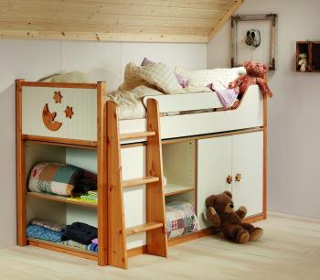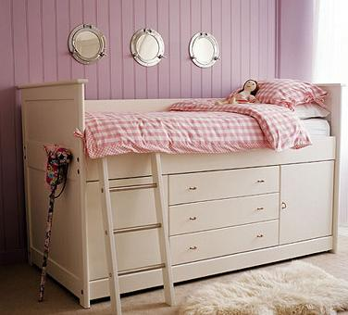

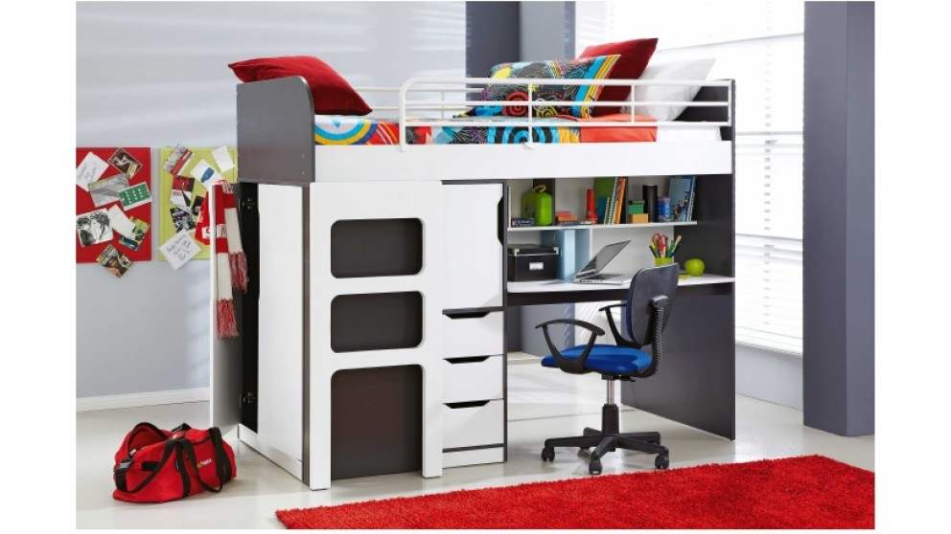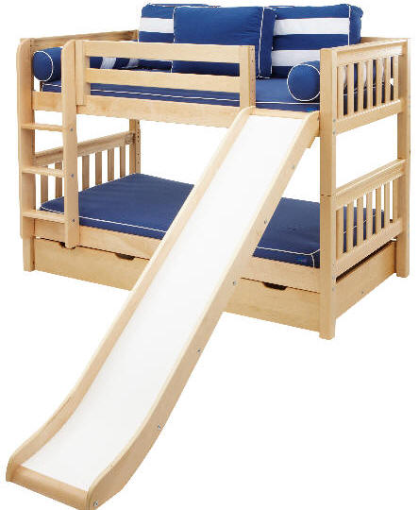

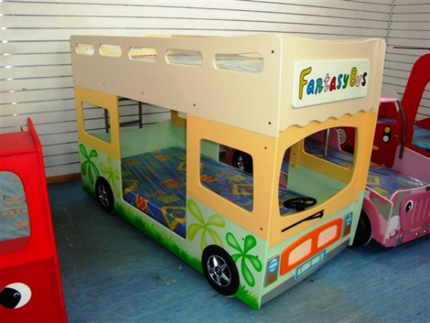

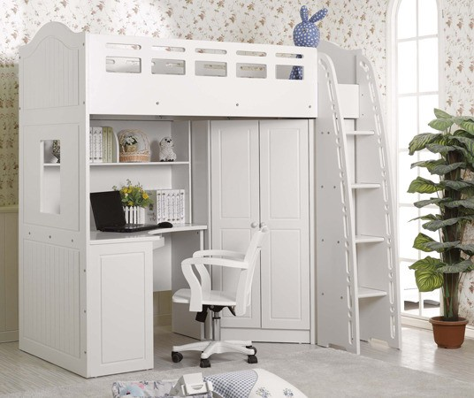

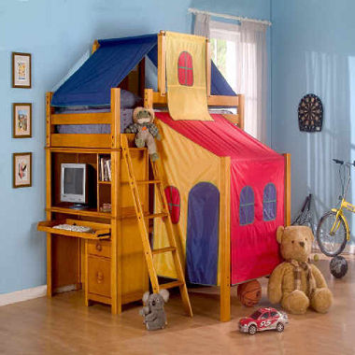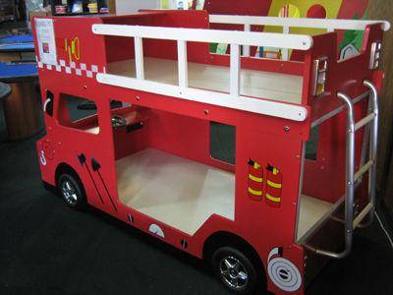

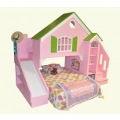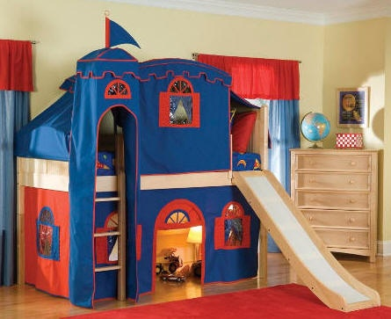

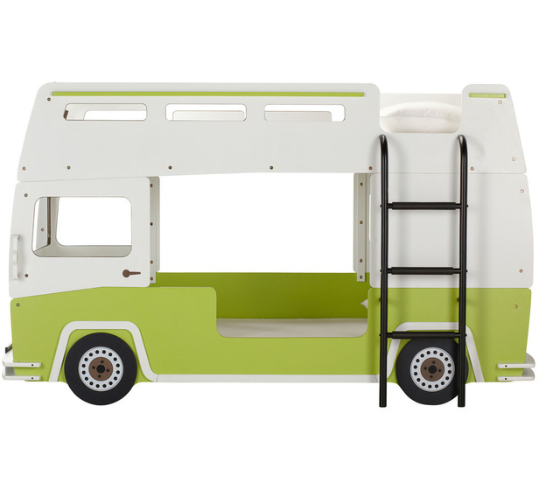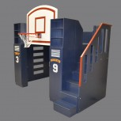

Appendix C - Product Recalls - summary

Year Supplier and model Issues

1998 Newtech Tube Company Bunk bed safety rail gap
Novakraft Bunk bed safety rail gap

2003 Associated Furnishers- Bonny Bunk Guard rail snag point

2005 Floline International – Sirocco Bunk Gaps and protrusions

2006 Furniture Galore – Fantasy Bus Bunk Gaps, base and guard rail issues
Eternal Design Pty Ltd - Fantasy Bus Gaps, base and guard rail issues

2007 Australian Discount Retail- Kids Bunk(2) Guard rail roll out issues
Hercules Iron- Asteroid and Comet Bunks Mattress base, entrapment and snagging

2008 Living Momentum- Euro and Ashford Bunks Snagging protrusions
Pacific Impexp Services-Bunk bed models Gaps and incomplete guard rails

2009 Infinity Megastore- Single and Double bunks Gaps and incomplete guard rails
Linksea- Snow Bunk Fall or entrapment hazard
ANE Furniture-Marina, Menzies, Casey Bunks Gaps in mattress supports and guard rails

2010 Sleepmaker- Lodger and Village Bunks Structural strength- collapse

2011 Furniture and Bedding Concepts- Jesse Entrapment and snag points
Fantastic Furniture- Bussy Bunk Entrapment and sharp edges
Portela Group- Angelotti Iron Bunk Entrapment and labelling
Furnituremate- Mezzaclick Bunk Falls, snag and entrapment
OzPlaza Living- Twin Bunk Snag hazard
Fantastic Furniture- Kelly, Bobbi, Disney Snag, mattress height labelling (roll out)
Fairies and Mojo High Sleeper

2012 Barezzi Furniture – Assorted bunks Snag points

2013 Le Cornu Furniture- Liza and Pluto Bunks Mattress height labelling (roll out)

Appendix D - Recent Enforcement Actions - Summary

ANE Furniture Ltd
Issues- Entrapment and snagging hazards, fall through hazards
July 2010

Linksea Pty Ltd
Issues- Entrapment hazards and potential roll out hazard with inadequate guard rail protection- February 2010

Pacific ImpExp Services
Issues-Incomplete guard rails around all four sides, fall through and entrapment hazards in guard rails, lack of maximum mattress height warning and supplier identification
May 2009

Sleep City Holdings
Issues- Entrapment and fall though hazards, lack of maximum mattress height warning and supplier identification
November 2008

Fantastic Furniture Pty Ltd
Issues- Fall out and entrapment hazards, lack of maximum mattress height warning and supplier identification
November 2008

Living Momentum Pty Ltd
Issues- Corner post protrusions, entrapment gaps, lack of maximum mattress height warning and supplier identification
July 2008

Australian Discount Retail Pty Ltd
Issues- Size of access opening, lack of maximum mattress height warning, corner post protrusions
March 2008

Eternal Design Pty Ltd
Issues- Entrapment and fall through hazards
January 2007

Furniture Galore Pty Ltd
Issues- Entrapment and fall out hazards
January 2007

Fair Trading (Safety Standards) Regulation 2011 (made under the Fair Trading Act 1989 (QLD))

