

|  |
| --- |
|  |
| Review of the  mandatory safety standard for disposable cigarette lighters  Consultation paper  October 2016 |
|  |

Disclaimer

The Australian Competition & Consumer Commission (ACCC) has developed this consultation paper to seek the views of stakeholders about the mandatory safety standard for disposable cigarette lighters.

© Commonwealth of Australia 2016. All material contained within this work is provided under a Creative Commons Attribution 3.0 Australia licence (creativecommons.org.au/), with the exception of any logos, illustrations or images. You may forward or otherwise distribute the paper. You may re-use the text in other formats, provided the ACCC is acknowledged as the source of the material and directions to access the full document are provided. You may not copy or reproduce any logos, illustrations or images. For more information, contact the Director Corporate Communications, ACCC, GPO Box 3131, Canberra ACT 2601

**Table of contents**

1. Introduction 4

2. Policy options 4

3. Background 4

4. Death and injuries 5

5. The current safety standard 6

6. Standards assessment and comparison 7

7. Detailed description of policy options 10

Option 1 – Keep the current mandatory safety standard (status quo) 10

Option 2 - Accept the voluntary Australian standard 10

Option 3 - Accept the voluntary Australian standard or multiple trusted international standards 11

Option 4 – Revoke the mandatory safety standard 12

8. Preliminary position 12

9. Multi-purpose lighters 13

10. Key questions 14

11. Have your say 14

12. Glossary 15

Appendix A: Warning symbols 16

Appendix B: Standards comparison for general safety requirements 17

Appendix C: Standards comparison for child resistance 20

1. Introduction

The ACCC is reviewing the mandatory safety standard for disposable cigarette lighters because:

* it was introduced 19 years ago and there are a number of deficiencies, particularly around clarity for suppliers regarding their testing and compliance obligations, which need to be addressed
* in 2002, Standards Australia introduced a voluntary Australian standard for general requirements and child resistance that the mandatory safety standard does not consider
* we are considering whether trusted international standards could be used as the basis for safety requirements in Australia.

**The consultation process outlined in this paper may be the only opportunity for you to provide input into this review.**

**You are encouraged to make a submission.**

1. Policy options

This consultation paper discusses four policy options:

|  |  |
| --- | --- |
| Option 1 | Keep the current mandatory safety standard (status quo) |
| Option 2 | Accept the voluntary Australian standard |
| Option 3 | Accept the voluntary Australian standard or multiple trusted international standards |
| Option 4 | Revoke the mandatory safety standard |

1. Background

Disposable cigarette lighters supplied in Australia are essentially the same as those supplied in other major international markets and, for the purposes of the mandatory safety standard, include some refillable lighters.[1]

The Australian market consists of products manufactured overseas, which are imported by distributors with a local network. There are no known Australian disposable cigarette lighter manufacturers.

The Australian Bureau of Statistics trade data from 2015 for the importation of gas fuelled non-refillable lighters indicated that 93 per cent of products came from France, with China and the Philippines each having a small percentage of the market. [2] The data for gas fuelled re-fillable lighters indicated that 55 per cent of imports came from China.[3]

1. Death and injuries

Disposable cigarette lighters are inherently hazardous, particularly in the hands of young children.

Between 1994 to 1997 prior to the introduction of the mandatory safety standard, coronial authorities and fire investigators linked nine deaths of Australian children under five years of age to the use of lighters.[4]

In terms of injuries, between 1986 and 1994, the Victorian Injury Surveillance System and the National Injury Surveillance Unit reported a high incidence of injury to children under five years of age. During this period 33 per cent of patients (61 out of 187) undergoing hospital treatment due to injuries caused by a lighter were children under five years of age.[5]

More recently, between 2002 and 2009, the ACCC has identified 17 deaths of children under five years of age.[6] These deaths were the result of 10 fires, eight of which were started by a child playing with a lighter and two where the probable cause was a lighter or matches. Six of the 10 fires resulted in multiple deaths.

Fire and Rescue NSW data indicated that between 1995 and 2014 they attended approximately 88 000 house fires. Over 900 of these fires involved children and lighters, 33 per cent of which resulted in injury. Of the fires relating to children and lighters 37 per cent involved children under the age of five. Fires involving lighters and children have resulted in an average of one death each year since 1996.

This data highlights that disposable cigarette lighters continue to be involved in house fires, deaths and injuries in young children. It also signals the ongoing importance for disposable cigarette lighters to feature a satisfactory child resistance mechanism. Further, the child resistance mechanism does not negate the need to ensure cigarette lighters are stored out of sight and reach of children.

In the United States, fire related deaths involving children playing with lighters dropped dramatically following the introduction of a safety standard in 1994.[7] There were 230 deaths and 11 100 residential fires in the United States in 1994 related to children playing with lighters. In 1998, there were 40 deaths and 6100 fires associated with children playing with lighters.[8] From 2000 to 2008, 139 children younger than age five died from fires associated with lighters. These figures represent a decrease in both house fires and deaths.[9]

1. The current safety standard

The mandatory safety standard was introduced in 1997 to reduce the risk of death and injuries to children under five years of age, and is based on the US Consumer Product Safety Commission (US CPSC) standard for cigarette lighters: 16 CFR, Chapter II, Part 1210 Safety standard for cigarette lighters (US CPSC standard).

The mandatory safety standard applies to disposable lighters, including some refillable lighters and novelty lighters designed to light cigarettes, cigars and pipes. Disposable cigarette lighters are defined in the mandatory safety standard as flame producing devices whether designed to be refilled with fuel or not with a customs value no more than the CPI (consumer price index) indexed amount.

The mandatory safety standard sets out requirements for:

* child resistance
* testing procedures
* ignition and adjustment of flame
* abnormal burning
* flame height
* flame extinction
* structural safety
* labelling
* certification.

The key deficiencies with the mandatory safety standard identified by the ACCC and addressed in this review include:

* Statutory declaration: a certificate of compliance with the US CPSC child resistance requirements must have been issued. However, a supplier may make a statutory declaration that a certificate of compliance exists, without reference to supporting documentation such as production records and test certificates. This is our only mandatory safety standard that allows compliance via a statutory declaration, which may be outdated and open to abuse.
* Test methods: there are no clear test methods specified for general safety-related performance requirements
* Warnings: the standard does not specify requirements that ensure adequate size, legibility, permanence and prominence of the warning text
* Price threshold: the CPI price threshold that sets the import price of lighters captured by the mandatory safety standard is difficult to administer and is not a viable determinant of the product risk. In 2002, the price threshold increased from $2 to $5 to capture some cheap imported refillable lighters. The US, Canada, and New Zealand apply similar price thresholds for lighters. However, the European standard avoids a price threshold by clearly defining requirements for refillable lighters.
* Traceability: there are no requirements for batch numbers making it difficult to trace a specific batch of lighters to the supply source.

1. Standards assessment and comparison

There are two distinct parts to the regulation of disposable cigarette lighters, general safety requirements and requirements for child resistance. The standards assessed for comparison with the mandatory safety standard address one or both of these requirements (Table 1).

**Table 1: Standards comparison for general and child resistance requirements**

|  |  |  |  |  |  |  |
| --- | --- | --- | --- | --- | --- | --- |
|  | Mandatory safety standard | Voluntary Australian standard | US CPSC standard | ASTM standard | European standard | ISO standard |
| General requirements | Similar to ISO 9994 | Part 1: picks up ISO 9994 | X | Similar to ISO 9994 | Picks up ISO 9994 | 🗸 |
| Child resistance | References US CPSC | Part 2: references US CPSC | 🗸 | References US CPSC | References US CPSC | X |

### Voluntary Australian standard

The voluntary Australian standardcomprises two parts.

Part 1 specifies general safety requirements including functional, structural and labelling requirements and test methods. It is out-of-date since it mirrors an older version of the International Organisation for Standardisation (ISO) standard published in 1995. The requirements are similar to those in the mandatory safety standard, although with more clearly defined test methods for performance and specifications for warning label requirements.

Part 2 specifies requirements for child resistance including methods for the force required to operate the child resistant feature and the durability of the child resistant mechanism.

### International standards

The international standards considered as part of this review include:

* US Consumer Product Safety Commission 16 CFR 1210 – Safety standard for cigarette lighters (US CPSC standard)
* EN 13869:2016 Lighters – Child Safety requirements for lighters – Safety requirements and test methods (European standard)
* ISO 9994:2005 Lighters – Safety specifications (ISO standard)
* ASTM F400-10 Standard consumer safety specification for lighters (ASTM standard)

The ACCC has assessed the international standards discussed below against the following criteria:[10]

* Addressing safety concerns: Is there evidence that the international standard provides an acceptable level of consumer safety?
* Comparable jurisdiction to Australia: Is the international standard published or developed by a legitimate standards body or government agency from an economy or nation with comparable economic and regulatory processes to Australia?
* Applicability to the Australian context: Is the international standard applicable and sufficient in the Australian context?

### General requirements

### ISO standard

The International Organisation for Standardisation (ISO) is an independent, non-governmental membership organisation and the world's largest developer of voluntary international standards. The ISO is a reputable standards development body.

The current version of the ISO standard was published in 2005 with an amendment made in 2008. Another update is expected to be published in late 2016.

The ISO standard establishes requirements for lighters to ensure a reasonable degree of safety for normal use or reasonably foreseeable misuse. It sets out requirements for functionality, structural integrity, test methods, instructions, warnings and product marking. These requirements are similar to those set out in the mandatory safety standard. However, the ISO standard more clearly defines test methods for performance and specifications for warning label requirements. The ISO standard also includes safety symbols in addition to text warning labels (see Appendix A).

The ACCC concludes that the ISO standard provides a level of safety for consumers that exceeds that of the mandatory safety standard and is appropriate for the Australian market. It is therefore suitable to be included in a policy option allowing compliance with trusted international standards (see Appendix B).

### ASTM standard

ASTM International, formerly known as the American Society for Testing and Materials (ASTM), is a United States organisation recognised globally for producing voluntary consensus standards.

The ASTM standard was adopted in 2010 and mirrors the ISO standardrequirements for functionality, structural integrity, test methods, instructions, warnings and product marking. As previously stated, these are similar to the requirements set out in the mandatory safety standard but include more clearly defined test methods for performance and specifications for warning label requirements. However, it does not pick up the use of safety symbols specified in the ISO standard. The ASTM standard also references the US CPSC standard for child resistance.

The ACCC concludes that the ASTM standard provides a level of safety for consumers that exceeds that of the mandatory safety standard and is appropriate for the Australian market. It is therefore suitable to be included in a policy option allowing compliance with trusted international standards (see Appendix B).

### Child resistance

### US CPSC standard

The US CPSC standard for lighters is mandatory in the United States and is published in the Code of Federation Regulations.[11] The Australian mandatory safety standard references the US CPSC standard for child resistance requirements.

The United States is a jurisdiction with comparable economic and regulatory processes to Australia. Part of the US CPSC’s role is drafting and enforcing mandatory standards to protect consumers from unsafe products. This role is similar to that of the ACCC Consumer Product Safety function.

All international standards considered as part of this review reference the US CPSC standard as the benchmark standard for child resistance requirements. The requirements for child resistance in the US CPSC standard include the use of a panel of children to test surrogate lighters for child resistance. These requirements make the lighters resistant to [successful operation](https://www.law.cornell.edu/definitions/index.php?width=840&height=800&iframe=true&def_id=37285b9f06f19d8cce5c1c879b17f1e7&term_occur=1&term_src=Title:16:Chapter:II:Subchapter:B:Part:1210:Subpart:A:1210.1) by children under five years of age.

The US CPSC standard requires a certificate of compliance to accompany each shipping unit of lighter, which states that the product complies with the US CPSC standard, the name and address of the manufacturer or importer issuing the certificate, the date and place of manufacture and an identification of the manufacturer.

The mandatory safety standard also requires that lighters are tested according to the US CPSC standard for child resistance and that a certificate of compliance within the meaning of the US CPSC standard has been issued. A statutory declaration stating that a certificate of compliance has been issued is also permitted in the absence of a test certificate being produced.

The ACCC concludes that the US CPSC standard provides a level of safety for consumers that exceeds the mandatory safety standard and is appropriate for the Australian market. It is therefore suitable to be included in a policy option allowing compliance with trusted international standards (see Appendix C).

### European standard

The European Committee for Standardization (CEN) is a not for profit reputable standards organisation which develops standards for use in Europe. Europe is a jurisdiction with comparable economic and regulatory processes to Australia.

On 4 February 2016 the CEN approved the European Standard, which specifies child resistance requirements based on the US CPSC standard and states that lighters shall comply with the ISO standard for general safety requirements.

The European standard provides more options than the mandatory safety standard for demonstrating compliance with child resistance requirements. It allows testing using the child test panel method prescribed in the US CPSC standard or sequential child panel testing. The sequential method allows a smaller number of children involved in testing depending on how many children can operate the lighter.

Certain mechanical test methods provide an alternative to the child test panel for some types of ignition mechanisms. A declaration of compliance and supporting documentation are required to accompany each shipping unit of lighters stating that the product complies with the European standard. The European standard has the same requirements for child resistance and similar compliance requirements as the mandatory safety standard.

The ACCC considers that the European standard provides a level of safety for consumers that exceeds that of the mandatory standard and is appropriate for the Australian market. It is therefore suitable to be included in a policy option allowing compliance with trusted international standards (see Appendix C).

1. Detailed description of policy options

## Option 1 – Keep the current mandatory safety standard (status quo)

### Description

### Maintaining the status quo would mean no changes to the mandatory safety standard. Disposable cigarette lighters would remain subject to the long-standing mandatory safety requirements that currently apply.

### Benefits

The penalties associated with breaching the mandatory safety standard would continue to apply and provide an incentive to suppliers to supply products in compliance with the requirements of the mandatory safety standard.

There would be no additional compliance and regulatory costs.

### Limitations

## The mandatory safety standard is out-of-date and has a number of deficiencies. This option would miss the opportunity to improve consumer safety and to clarify supplier compliance requirements.

## Option 2 - Accept the voluntary Australian standard

### Description

### The mandatory safety standard would be updated to allow suppliers to comply with the voluntary Australian standard.

### Benefits

### Given the voluntary Australian standard is based on international standards for general requirements and child resistance, and a significant proportion of the market tests to these standards, we would anticipate minimal impact on industry.

Part 1 of the voluntary Australian standard mirrors the general safety requirements in the ISO standard so importers would not have significant additional obligations when importing products for the Australian market.

Part 2 of the voluntary Australian standard outlines test methods, which can verify compliance with the child resistant characteristics of the US CPSC standard and would provide suppliers with an alternative to the child test panel.

### Limitations

The voluntary Australian standard is based on a 1995 version of the ISO standard and has not been updated since 2002. It is also therefore potentially out-of-date. In 2005, the ISO standard was updated to include safety symbols, which can be used instead of a safety warning statement (see Appendix A).

When compared with option 3, there would also be fewer options for suppliers to demonstrate compliance, which could increase the administrative and regulatory burden.

## Option 3 - Accept the voluntary Australian standard or multiple trusted international standards

### Description

The mandatory safety standard would be updated to allow suppliers to comply with either the voluntary Australian standard Part 1, the ISO standard or the ASTM standard for general safety requirements and either the voluntary Australian standard Part 2, the US CPSC standard or the European standard for child resistance requirements.

### Benefits

Adopting these standards would address the deficiencies identified with the mandatory safety standard.

The voluntary Australian standard Part 1, the ISO standard or the ASTM standard would address the following general safety requirements:

* These standards clearly outline test methods including descriptions of the test apparatus, test procedure and the test results that constitute a failure. The mandatory safety standard currently lacks clear test protocols for flame testing and structural integrity.
* These standards specify the text size, legibility, permanence and prominence requirements for the safety warning. The mandatory standard currently lacks clarification around labelling requirements.

Accepting the voluntary Australian standard Part 2, the US CPSC standard or the European standard would address the following child resistance requirements:

* Distributors (including retailers) are required to hold documentation that identifies the source of their supplies, so they can produce it on request. Currently it is difficult to establish that a certificate of compliance relates to a particular lighter or model of lighter.
* A declaration of compliance must accompany each shipping unit of the product stating that all lighters in each batch comply with the model tested and include supporting documentation. The mandatory safety standard requires a statutory declaration that a certificate of compliance has been issued but does not require the test certificate to also be produced.

Suppliers of disposable cigarette lighters are already required to ensure that their products comply with general safety and child resistance requirements. This would not change under this option. However, there would be more options for suppliers to demonstrate compliance and this could reduce the administrative and regulatory burden on businesses.

### Limitations

Business importing to Australia may incur some additional costs under this option to provide a test certificate of compliance with the child resistance requirements.

## Option 4 – Revoke the mandatory safety standard

### Description

The mandatory safety standard would be revoked and industry would be allowed to self-regulate. Most consumer goods in Australia are not regulated by mandatory safety standards. Revoking the mandatory safety standard would mean suppliers would still need to have regard to the consumer protection provisions of the Australian Consumer Law (ACL). The ACL provides consumers with specific protections for consumer transactions called statutory consumer guarantees every time they purchase goods or services. One of those guarantees is that goods will be of acceptable quality, meaning they are safe and fit for purpose.

Consumer protections also exist to safeguard against suppliers engaging in conduct that is likely to be misleading or deceptive. Additionally, there are provisions for injury reporting, recalls and product liability. These provisions give suppliers an incentive to ensure that the goods they supply are safe. The ACCC would still be able to take safety action if needed – for example, through recalls.

### Benefits

There would be no direct compliance costs for industry under this option. Any international trade restrictions resulting from the current mandatory safety standard would be removed, making it easier for businesses to import products to Australia. This may result in lower priced lighters becoming available to Australian consumers. It also sends a message of confidence to business that they will invest in and maintain appropriate industry stewardship.

### Limitations

The removal of mandatory requirements for flame testing, structural safety, labelling and child resistance presents the potential for unsafe lighters to enter the market. As mentioned, disposable cigarette lighters are inherently hazardous, particularly in the hands of young children and revoking mandatory safety requirements could lead to an increase in death and serious injury from fires.

1. Preliminary position

The ACCC is currently of the view that Option 3 is likely to provide the greatest net benefit for consumers, suppliers and regulators. Stakeholder submissions to this consultation will help us test the position and to recommend the most appropriate option to the Minister.

The Office of Best Practice Regulation (OBPR) has advised that a Regulation Impact Statement (RIS) is not required as the proposed changes are administrative and minor.

1. Multi-purpose lighters

The ACCC is aware of three deaths (two children aged five years and a six year old) between 2007 and 2014 resulting from children playing with multi-purpose lighters.[12] Other countries currently regulate, (e.g. US) or are considering whether to regulate these products (e.g. New Zealand).

Multi-purpose lighters are hand held, flame producing products that operate on fuel, incorporate an ignition mechanism and are used to light candles, fireplaces, charcoal or gas barbeques, camp fires, camp stoves, lanterns, fuel-fired appliances or devices, pilot lights or for soldering or brazing.

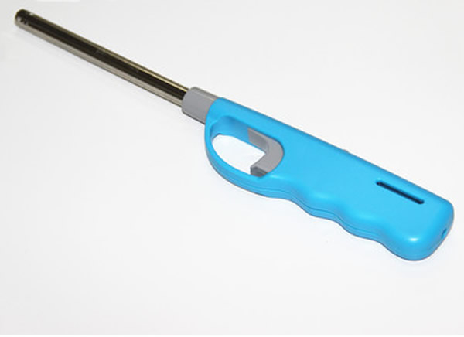

There is an ISO standard for utility lighters *ISO 22702:2003/Amd 1:2008 Utility lighters - General consumer-safety requirements - Amendment 1: Clarification of requirements and addition of safety symbols.* This standard establishes requirements to ensure a reasonable degree of safety for normal use or reasonably foreseeable misuse.

In the United States, there is a mandatory standard *16 CFR 1212 – Safety standards for multi-purpose lighters*. The mandatory standard makes it harder for children under five years of age to successfully operate multipurpose lighters.

Some multi-purpose lighters tested to the US CPSC standard are available for sale in Australia, but not all products on the market have a child resistant safety feature. It is difficult to ascertain the number of injuries occurring because of these products, due to the ignition source not being explicitly specified in many cases involving children and fire play.

The ACCC has included questions at section 10 about multi-purpose lighters in Australia to help inform whether a future regulatory proposal for this type of product is required.

1. Key questions
2. Do you agree with the ACCC’s assessment of international standards for disposable cigarette lighters?
3. Do you think that these proposals would reduce regulatory burden on suppliers?   
   If so, by how much?
4. Are there any other safety hazards that we have not considered?
5. Which policy option do you support and why?
6. Disposable cigarette lighters are manufactured for a global market. Should we consider the out of date voluntary Australian standard?
7. Are there any other policy options that the ACCC should consider?
8. How much time should the ACCC allow for suppliers to transition to the new mandatory safety standard?
9. Do you have any other comments?
10. Do you think multi-purpose lighters should be considered for a future regulatory proposal?
11. Do you have any other comments in relation to multi-purpose lighters?
12. Have your say

The ACCC invites interested parties to provide information and comment on this review. Consultation is open from 12 October to 25 November 2016.

The ACCC prefers submissions to be made via the ACCC consultation hub at [consultation.accc.gov.au](https://consultation.accc.gov.au).

Alternatively, email submissions to [productsafety.regulation@accc.gov.au](mailto:productsafety.regulation@accc.gov.au).

Submissions can also be posted to:

Director  
Standards and Policy  
Consumer Product Safety Branch  
Australian Competition and Consumer Commission  
GPO Box 3131  
CANBERRA ACT 2601

If the information you provide is of a confidential nature, we assure you that we will treat the details you provided confidentially. That is, the ACCC will not disclose the confidential information to third parties, other than advisors or consultants engaged directly by the ACCC, without first providing you with notice of its intention to do so, such as where it is compelled to do so by law. Please note that any information that you believe to be of a confidential nature should be clearly marked or identified as confidential. See the [ACCC & AER information policy: collection and disclosure of information](http://www.accc.gov.au/system/files/ACCC-AER%20Information%20Policy.pdf) publication for more information.

1. Glossary

| **Term** | **Definition** |
| --- | --- |
| **Adjustable cigarette lighter** | A lighter with a mechanism for flame height adjustment |
| **ASTM standard** | American National Standard – ASTM F400-10 Standard consumer safety specification for lighters |
| **Australian Consumer Law (ACL)** | Legislation in Schedule 2 of the *Competition and Consumer Act 2010* (Cth) and applied nationally through State and Territory legislation |
| **Disposable cigarette lighter** | A flame producing device that is designed to light cigarettes, cigars and pipes as defined in the mandatory safety standard |
| **European standard** | EN 13869:2016 Lighters – Child Safety requirements for lighters – Safety requirements and test methods |
| **ISO standard** | ISO 9994: 2005 Lighters – safety specifications |
| **ISO standard (utility lighters)** | ISO 22702:2003/Amd1:2008 Utility lighters - General consumer-safety requirements - Amendment 1: Clarification of requirements and addition of safety symbols |
| **Mandatory safety standard** | [Trade Practices (Consumer Product Safety Standard) (Disposable Cigarette Lighters) Regulations 1997](https://www.legislation.gov.au/Details/F2004C00665) |
| **Refillable cigarette lighter** | A lighter that is designed to be refilled with fuel and is not valued more than the import price specified in the mandatory safety standard |
| **US CPSC standard** | US Consumer Product Safety Commission 16 CFR 1210 – Safety standard for cigarette lighters |
| **US CPSC standard (multi-purpose lighters)** | US Consumer Product Safety Commission 16 CFR 1212 – Safety standards for multi-purpose lighters |
| **Voluntary Australian standard – Part 1** | AS/NZS 4867.1:2002 (ISO 9994:1995) Cigarette Lighters: General requirements |
| **Voluntary Australian standard – Part 2** | AS/NZS 4867.2:2002 Cigarette Lighters: Child resistance requirements |

Appendix A: Warning symbols

The ISO standard specifies that safety information shall be conspicuously placed, with a contrasting background, colour and a type size or style that is distinct from other information.

It also allows the use of symbols either with or without the warning text, which provides an alternative for suppliers to comply with warning label requirements.

Requirements set out specifications such as colour, background colour and minimum size. If safety symbols are used, they should have the same proportions as those shown below:

1. **“WARNING” symbol**

or



1. **“KEEP AWAY FROM CHILDREN” symbol**



1. **“CAUTION, RISK OF FIRE” symbol**

or

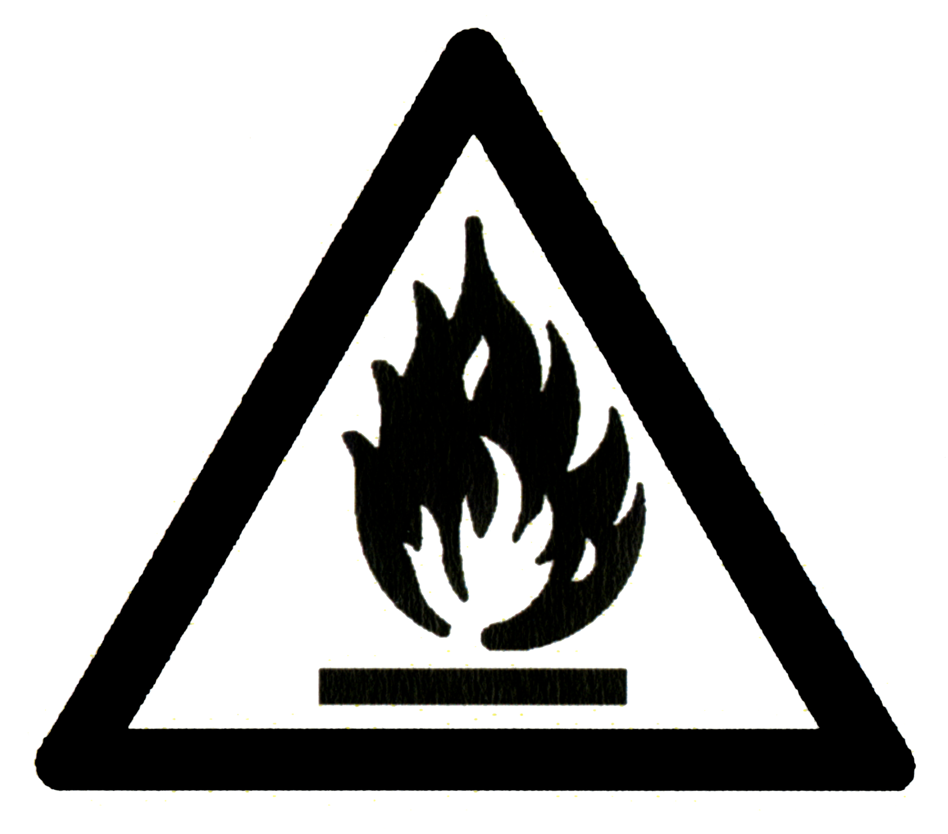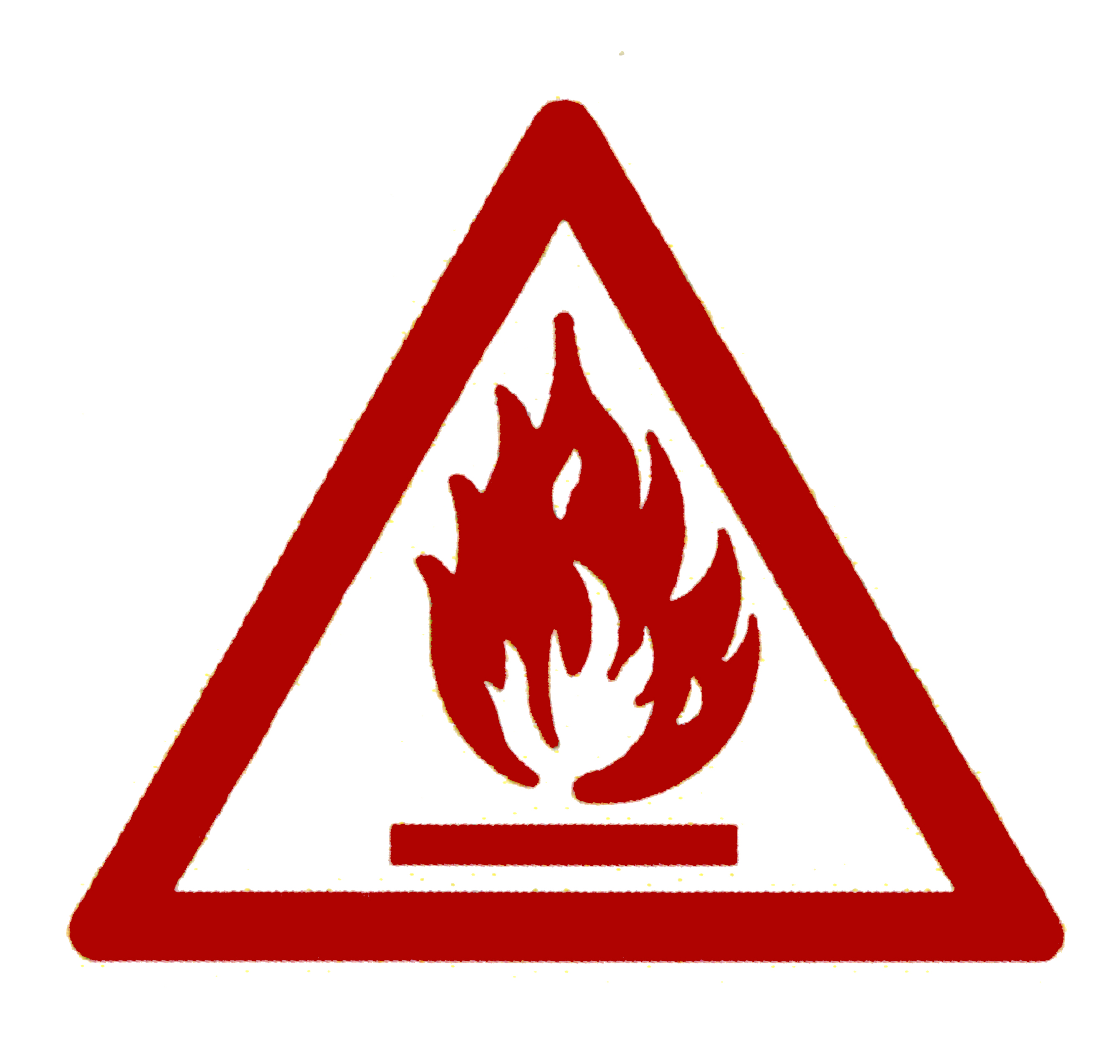

1. **NEVER EXPOSE TO HEAT ABOVE 50°C OR TO PROLONGED SUNLIGHT” symbol**

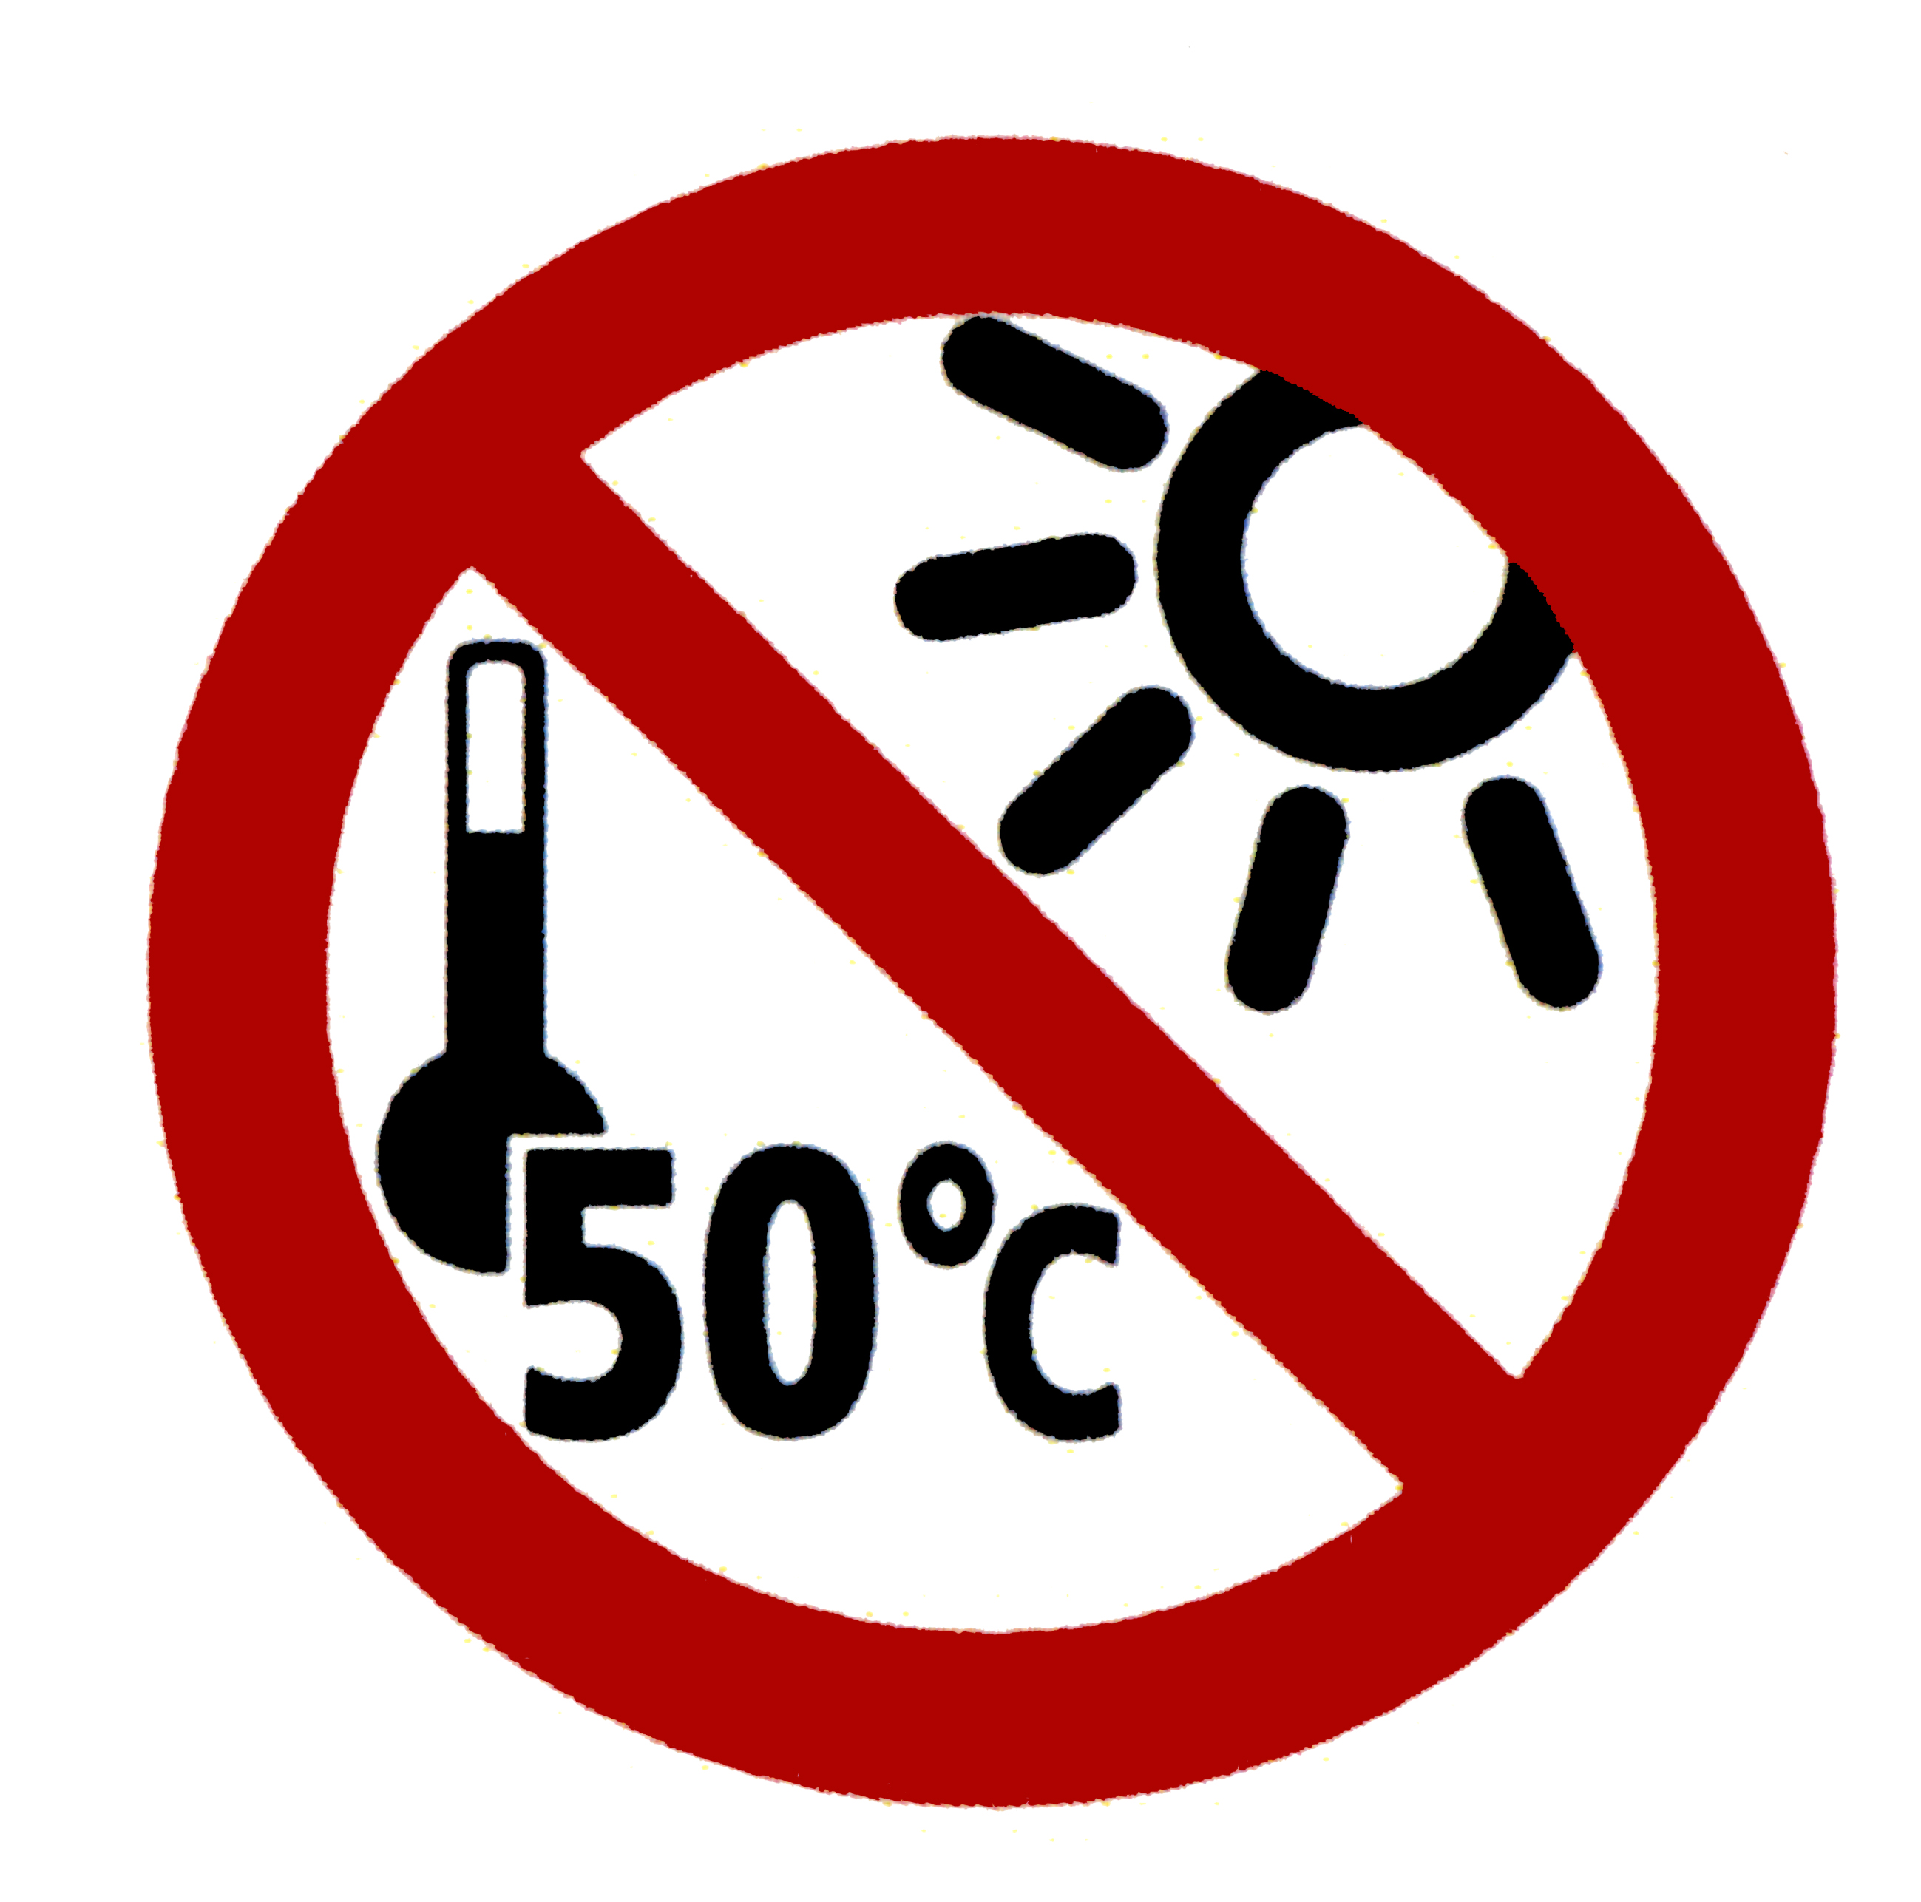

Appendix B: Standards comparison for general safety requirements

| **Key requirements** | **Mandatory safety standard** | **Voluntary Australian standard** | **ISO standard** | **ASTM standard** |
| --- | --- | --- | --- | --- |
| **Functional requirements** | | | | |
| **Flame generation** | 🗸 | 🗸 | 🗸 | 🗸 |
| **Flame height** | 🗸 | 🗸 | 🗸 | 🗸 |
| **Flame height adjustment** | 🗸 | 🗸 | 🗸 | 🗸 |
| **Resistance to spitting, sputtering and flaring** | 🗸 | 🗸 | 🗸 | 🗸 |
| **Flame extinction** | 🗸 | 🗸 | 🗸 | 🗸 |
| **Volumetric displacement** | X | 🗸 | 🗸 | 🗸 |
| **Structural integrity requirements** | | | | |
| **External finish** | 🗸 | 🗸 | 🗸 | 🗸 |
| **Compatibility with fuel** | X | 🗸 | 🗸 | 🗸 |
| **Resistance to fuel loss** | X | 🗸 | 🗸 | 🗸 |
| **Resistance to dropping** | 🗸 | 🗸 | 🗸 | 🗸 |
| **Resistance to elevated temperature** | 🗸 | 🗸 | 🗸 | 🗸 |
| **Resistance to internal pressure** | 🗸 | 🗸 | 🗸 | 🗸 |
| **Burning behaviour** | 🗸 | 🗸 | 🗸 | 🗸 |
| **Resistance to cyclic burning** | X | 🗸 | 🗸 | 🗸 |
| **Resistance to continuous burning** | X | 🗸 | 🗸 | 🗸 |
| **Test methods** | | | | |
| **Test specimens** | 🗸 | 🗸 | 🗸 | 🗸 |
| **Flame height measurement** | 🗸 | 🗸 | 🗸 | 🗸 |
| **Spitting, sputtering and flaring** | X | 🗸 | 🗸 | 🗸 |
| **Flame extinction** | X | 🗸 | 🗸 | 🗸 |
| **Fuel compatibility** | X | 🗸 | 🗸 | 🗸 |
| **Refilling** | X | 🗸 | 🗸 | 🗸 |
| **Volumetric fuel displacement** | X | 🗸 | 🗸 | 🗸 |
| **Drop test** | 🗸 | 🗸 | 🗸 | 🗸 |
| **Elevated temperature** | 🗸 | 🗸 | 🗸 | 🗸 |
| **Internal pressure** | 🗸 | 🗸 | 🗸 | 🗸 |
| **Cyclic burning time** | X | 🗸 | 🗸 | 🗸 |
| **Continuous burning time** | X | 🗸 | 🗸 | 🗸 |
| **Instructions and warnings** | | | | |
| **General** | 🗸 | 🗸 | 🗸 | 🗸 |
| **Location** | 🗸 | 🗸 | 🗸 | 🗸 |
| **Content** | 🗸 | 🗸 | 🗸 | 🗸 |
| **Safety symbols** | X | X | 🗸 | X |
| **Product marking** | 🗸 | 🗸 | 🗸 | 🗸 |

Appendix C: Standards comparison for child resistance

|  | **Mandatory safety standard** | **Voluntary Australian standard** | **US CPSC standard** | **European standard** |
| --- | --- | --- | --- | --- |
| **Reference to other standards** | US CPSC standard for child resistant requirements | US CPSC standard for child resistant requirements | x | US CPSC standard for child resistant requirements |
| **Testing procedures** | Child test panel as prescribed in the US CPSC standard | Provides test methods to validate child resistant characteristics of the test lighter used in a child test panel | Child test panel to test a surrogate lighter representing a production lighter | Child test panel as prescribed in the US CPSC standard. Operating button force test for certain types of lighters |
| **Child resistance** | All standards specify that child resistant characteristics shall comply with the US CPSC standard which states:   * a lighter shall be resistant to successful operation by at least 85 % of the child test panel * the mechanism must reset automatically after operation * it must not impair safe operation when used in a normal manner * it must be effective for the reasonably expected life of the lighter and * not be easily overridden or deactivated. | | | |

1. Glossary p.16
2. Department of Foreign Affairs and Trade, Free Trade Agreement Portal, pocket lighters, gas fuelled, non-refillable, import market viewed 6 September 2016 [ftaportal.dfat.gov.au/CHN/ChAFTA/product/96131000/market?expanded=9613](https://ftaportal.dfat.gov.au/CHN/ChAFTA/product/96131000/market?expanded=9613)
3. Department of Foreign Affairs and Trade, Free Trade Agreement Portal - pocket lighters, gas fuelled refillable, import market viewed 6 September 2016 [ftaportal.dfat.gov.au/CHN/ChAFTA/product/96132000/market?expanded=9613](https://ftaportal.dfat.gov.au/CHN/ChAFTA/product/96132000/market?expanded=9613)
4. Australian Government, Federal Register of Legislation, Trade Practices (Consumer Product Safety Standard) (Disposable Cigarette Lighters) Amendment Regulations 2002 (No. 1) 2002 No. 343, viewed, 15 August 2015, [www.legislation.gov.au/Details/F2002B00350/Explanatory%20Statement/Text](http://www.legislation.gov.au/Details/F2002B00350/Explanatory%20Statement/Text)
5. Regulation Impact Statement, Trade Practices Act 1974 Consumer Product Safety Standard for Disposable Cigarette Lighters
6. The ACCC reviewed confidential data from the National Coronial Information System (NCIS) ([www.ncis.org.au](http://www.ncis.org.au)). There may be deaths that we did not identify due to either missing data or because cases were still open.
7. United States Consumer Product Safety Commission website, News release number 01026 2 November 2000, [www.cpsc.gov/en/Newsroom/News-Releases/2001/Child-Resistant-Lighters-Bring-Down-Fire-Deaths-CPSC-report-shows-43-decline-in-deaths-from-lighter-fires/](http://www.cpsc.gov/en/Newsroom/News-Releases/2001/Child-Resistant-Lighters-Bring-Down-Fire-Deaths-CPSC-report-shows-43-decline-in-deaths-from-lighter-fires/)
8. ibid
9. United States Consumer Product Safety Commission, Federal Register Notice Regarding Adjusted Customs Value for Refillable Cigarette Lighters Under 16 C.F.R. part 1210, 14 August 2013, [www.cpsc.gov/Global/Newsroom/FOIA/CommissionBriefingPackages/2013/AdjustedCustomsValueRefillableCigaretteLightersUnder16.pdf](http://www.cpsc.gov/Global/Newsroom/FOIA/CommissionBriefingPackages/2013/AdjustedCustomsValueRefillableCigaretteLightersUnder16.pdf)
10. ACCC, International standards for the safety of consumer products - criteria for acceptance, ACCC policy principles, 22 July 2015, [www.productsafety.gov.au/content/index.phtml/itemId/1014180](http://www.productsafety.gov.au/content/index.phtml/itemId/1014180)
11. Cornell University Law School, Legal Information Institute, Code of Federal Regulations 16CFR Part 1210, viewed 20 September 2016 [www.law.cornell.edu/cfr/text/16/part-1210](https://www.law.cornell.edu/cfr/text/16/part-1210)
12. The ACCC reviewed confidential data from the National Coronial Information System (NCIS) ([www.ncis.org.au](http://www.ncis.org.au)). There may be deaths that we did not identify due to either missing data or because cases were still open.